ECE 5730 · DIGITAL SYSTEMS DESIGN USING MICROCONTROLLERS
Lab 3 Report
PID Control of a 1D Helicopter
Amber Li | Ivan Huang | Zarif Karim
Thursday lab section · 11.08.2026
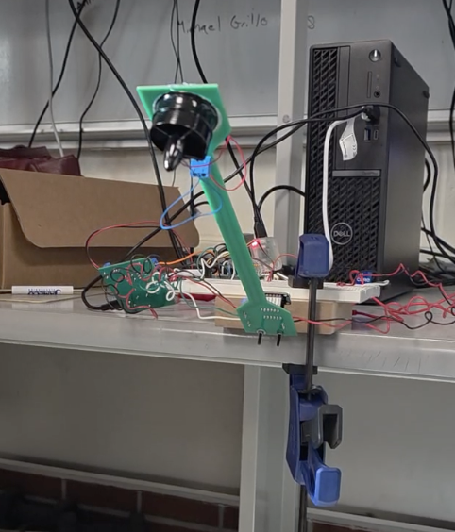
The arm holding +30° above horizontal during the demo sequence.

Contents
1 Introduction
2 Mathematical and Physical Background
2.1 Measuring angle · 2.2 Complementary filter · 2.3 Plant model · 2.4 PID control · 2.5 Practical PID problems · 2.6 PWM and the motor circuit · 2.7 Fixed point · 2.8 I2C
3 Design and Testing Methods
3.1 Build order and debugging · 3.2 Motor driver · 3.3 PWM · 3.4 IMU · 3.5 Control ISR · 3.6 Overcurrent protection and anti-windup · 3.7 Demo sequence · 3.8 VGA · 3.9 Serial · 3.10 Wiring
4 Documentation
5 Results
5.1 Final gains · 5.2 Demo sequence · 5.3 Settling times · 5.4 Hover duty vs. angle · 5.5 Stable range · 5.6 Earlier tuning runs
6 Conclusion
7 Answers to the Lab Report Questions
8 Work Distribution and AI Use
References
Appendix A Commented Code Listing
Appendix B AI Prompt Log

1 Introduction
We built and controlled a one-degree-of-freedom "helicopter": a lever arm on a hinge with a ducted motor at the free end. An MPU-6050 IMU on the arm reports acceleration and angular rate over I2C. A Raspberry Pi Pico 2 (RP2350) fuses the two with a complementary filter to estimate the arm angle, and a PID controller running at exactly 1 kHz (inside the PWM-wrap interrupt) sets the motor's PWM duty cycle through an optically isolated MOSFET driver.
The target angle and all three gains are set from a serial terminal and take effect on the next 1 ms cycle. A VGA display plots the measured angle against the target and the controller's motor command in real time. A pushbutton runs the demo: while it is held, the motor is off and the arm hangs at −90°; on release the target steps to 0°, then +30° at 5 s, −30° at 10 s and 0° at 15 s, using whatever gains are loaded. With our final gains (K_{p} = 80, K_{i} = 0.2, K_{d} = 12) the arm reached every demo angle and settled in 1–3.6 s, and stayed stable from −90° to about +50°.
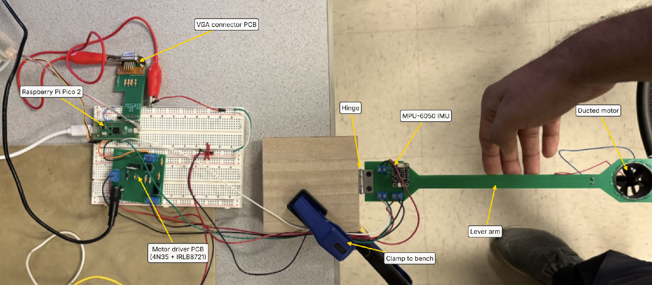
Figure 1. The rig from above: Pico 2 and VGA adapter on the breadboard, the motor-driver PCB, the hinge clamped to the bench, the IMU next to the hinge and the ducted motor at the end of the arm.
Angle convention. Throughout the report and code, 0° is the arm horizontal, −90° is hanging straight down (the handout's −1.57 rad starting position) and positive angles are above horizontal. The course's analytical notes measure θ from hanging down instead; where we use their equations, θ = φ + 90°, where φ is our angle.

2 Mathematical and Physical Background

2.1 Measuring angle: accelerometer vs. gyroscope
An accelerometer measures specific force, the acceleration it feels minus gravity. At rest it reads 1 g pointing up (the normal force from the table), and in free fall it reads zero. When the arm is still, the measured vector is gravity itself, so its direction in the IMU frame gives the tilt (Figure 2a). The arm pivots about the IMU's y axis, so gravity moves between the x and z axes. Because the arm swings through 140° and more, the small-angle approximation θ ≈ a_{x}/g is useless here and we use the full four-quadrant arctangent:
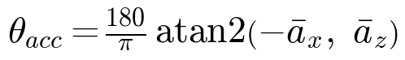
The bars mean the readings are low-passed first (Section 2.2). The accelerometer angle never drifts, because gravity is always there, and its noise is roughly zero-mean, so it is unbiased on average. But any other acceleration looks like a tilt: motor vibration and the arm's own swinging make it very noisy once the motor runs (Figure 19).
The gyroscope measures angular rate ω_{y} (°/s). Integrating it gives an angle that is very smooth over short times and ignores vibration, but every gyro has a small bias b, so the integral drifts without bound (dead reckoning):
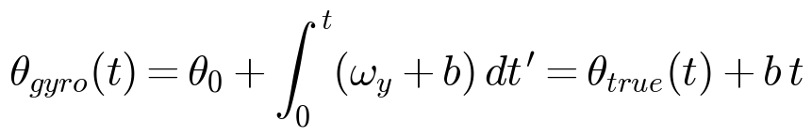
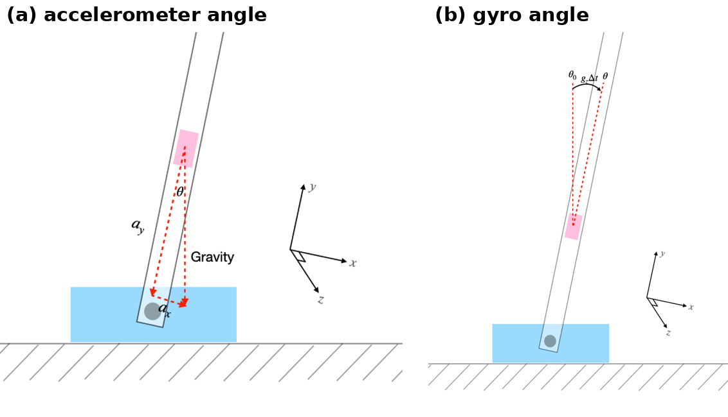
Figure 2. (a) The accelerometer angle comes from the direction of gravity. (b) The gyro angle adds rate × Δt each step. From the course complementary-filter notes, which label the axes a_{y} and g_{z}; on our board the matching axes are a_{z} and gyro y.

2.2 The complementary filter
Each sensor fails where the other is good: the accelerometer is trustworthy at low frequency (long term), the gyro at high frequency (short term). Every 1 ms the ISR adds the gyro's angle change to the previous estimate and nudges the result 0.1% toward the accelerometer angle (Figure 3):
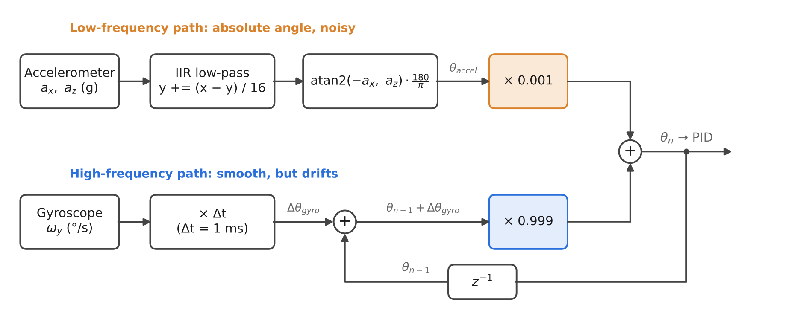
Figure 3. Our complementary filter as implemented in on_pwm_wrap().
Why it is called complementary. Taking this update in the continuous limit (α = 0.999, Δt = 1 ms) gives a first-order low-pass on the accelerometer and a first-order high-pass on the gyro angle with the same time constant:
The two filters add to exactly 1, so the true angle passes through undistorted at every frequency; only each sensor's noise is filtered. Below about 1/(2πτ) ≈ 0.16 Hz the estimate follows the accelerometer; above it, the gyro. Two consequences follow directly from the transfer function:
- Gyro bias becomes a small constant offset instead of drift. A constant bias b integrates to a ramp b/s²; through the high-pass it settles to
An uncalibrated MPU-6050 can have a bias of a few °/s, so subtracting a measured bias at start-up would be the next improvement (Section 6).
- The weight trades noise for bias. The notes suggest 0.99/0.01; we used 0.999/0.001, which moves the crossover down ten times and keeps more motor vibration out, at the cost of a larger bias offset (τ = 1 s instead of 0.1 s). With the motor running, our accelerometer readout differed from the complementary angle by 2–5° at any instant while the complementary trace stayed smooth (compare the two readouts in the screenshots of Section 5.2).
Low-pass before atan2. atan2 is nonlinear, so zero-mean noise on a_{x} and a_{z} does not average out after it: the noisy angle comes out biased. We therefore filter the raw axes first with a first-order IIR, the digital version of an RC filter (forward-Euler discretisation, as derived on the course Display page):
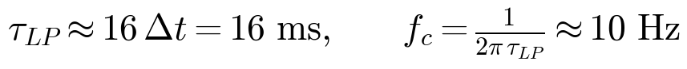
This adds about 16 ms of lag, but only to the accelerometer path, which carries 0.1% weight. The gyro path, which dominates at control frequencies, has no lag. This is why we did not simply low-pass the accelerometer and skip the gyro: a filter slow enough to remove vibration would add tens of milliseconds of phase lag inside the control loop, and lag is exactly what destabilises a feedback loop (Section 2.4).

2.3 Modeling the plant
The analytical PID notes model the system as a motor (voltage to rotor speed ω) in series with the arm (ω to angle). Motor. An armature with resistance R, inductance L and back-EMF constant K, driving inertia J with viscous drag b, gives a two-pole low-pass:
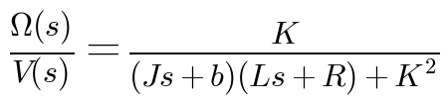
Both poles are fast compared with the arm, so from the arm's point of view the motor speed follows the applied voltage almost instantly. The arm dominates the loop dynamics.
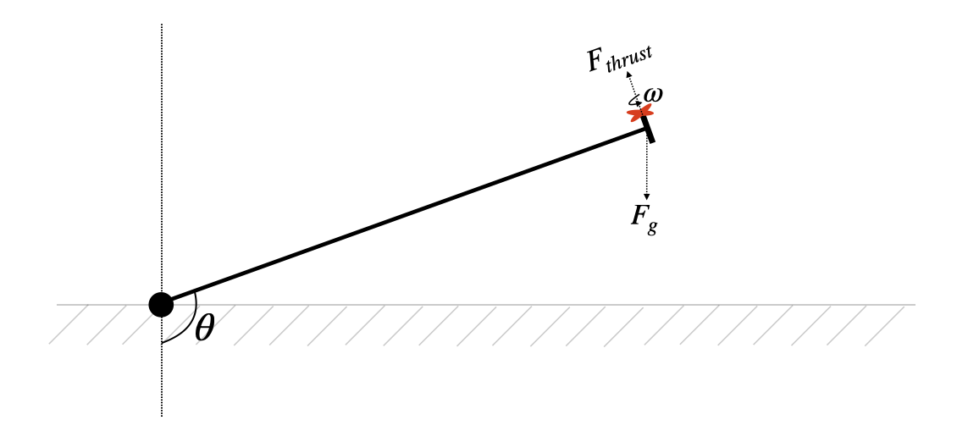
Figure 4. Thrust and gravity on the arm, with θ measured from hanging down. From the course PID notes.
Arm. Thrust is roughly K_{T}ω², always perpendicular to the arm; gravity acts on the motor mass m at distance L; hinge friction is K_{f}θ̇. Treating the arm as a point mass at its end, the torque balance is
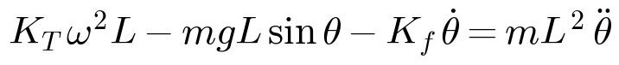
Linearising about an operating point (θ₀, ω₀) and taking the Laplace transform:
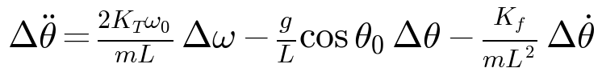
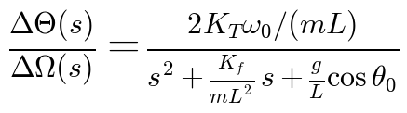
This is a lightly damped resonance whose "spring constant" is (g/L) cos θ₀. Three things follow, and each showed up in lab:
- Hanging down (θ₀ = 0) the arm is a pendulum with natural frequency √(g/L): 5.7 rad/s (0.9 Hz) for the notes' 0.3 m arm. We did not measure our arm's length precisely.
- Gravity's stiffness changes sign at horizontal (θ₀ = 90°, cos = 0). Below horizontal gravity pulls the arm back toward equilibrium; above it, gravity pushes the arm further away, so above horizontal only the controller keeps the arm up.
- The plant gain 2K_{T}ω₀/(mL) depends on the operating point. At angles that need less thrust the motor spins slower, so each extra duty count moves the arm less. One set of fixed gains cannot be ideal at every angle, which is part of why the stable range is limited (Section 5.5).
Thrust needed to hover. Setting all derivatives to zero in the torque balance:
So the ideal point-mass arm needs the most thrust at horizontal and equal thrust at ±30° (cos 30° = 0.87). On our rig the duct hangs below the arm (photo in Figure 14), so the centre of mass sits a distance d below the arm's centre line. The gravity torque then becomes
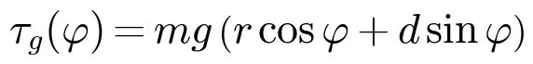
which needs more thrust above horizontal than below it. Section 5.4 shows our measured hover duties have exactly this asymmetry.

2.4 PID control
Open-loop control (a lookup table from desired angle to duty cycle) fails here because the thrust needed changes with the supply voltage, motor temperature, air density and the arm's wiring, and nothing corrects a bump. We close the loop instead (Figure 5): measure the angle, compare it with the target, and let the controller turn the error into a motor command.
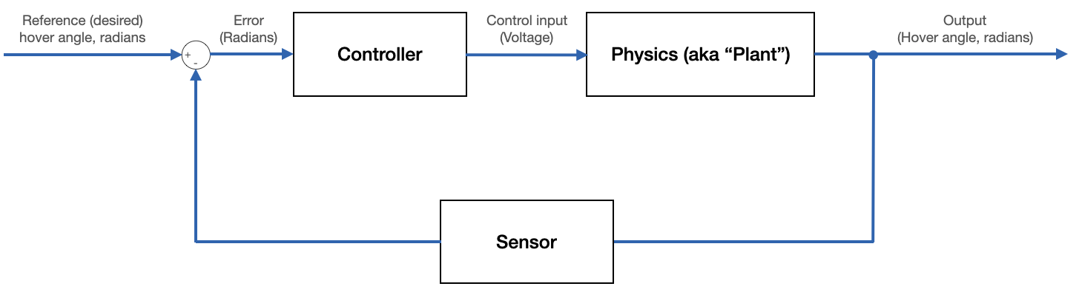
Figure 5. Closed-loop control. From the course PID notes.
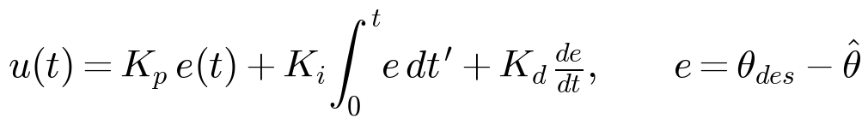
- Proportional reacts to the error right now (Figure 6a). Alone it leaves a steady-state error: holding the arm up needs a non-zero command, and P only produces one if the error is non-zero. Too much K_{p} makes the arm oscillate.
- Integral reacts to the accumulated error, the area under the curve (Figure 6b). It removes steady-state error: at rest P ≈ 0 and D ≈ 0, so the I term alone supplies the hover thrust. It adds 90° of phase lag, so K_{i} is kept small.
- Derivative reacts to how fast the error is changing. It opposes fast approaches, which adds damping.
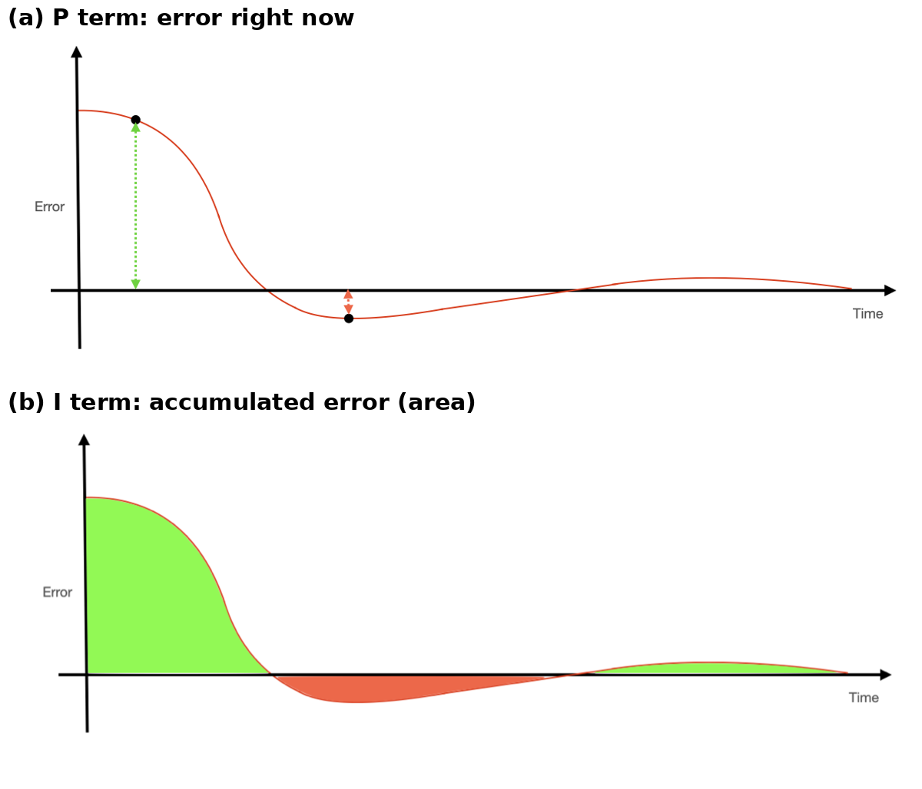
Figure 6. (a) P acts on the error at this instant. (b) I acts on the area under the error curve, positive and negative. From the course PID notes.
D from the gyro. The target only changes in steps, so between steps its derivative is zero and
We feed the gyro rate straight into the D term (the approach recommended in lecture) instead of differencing the angle estimate. Differencing multiplies noise by its frequency, and at 1 kHz the change in angle from one sample to the next is smaller than the noise. Using −ω_{y} also means a setpoint step produces no derivative spike ("derivative kick"), because the gyro does not see the target.
Discrete law as implemented. Every 1 ms the ISR computes
where u_{lim} is the slew-limited ceiling of Section 3.6. The integrator accumulates K_{i}e (already in duty counts) rather than Σe, so changing K_{i} never makes the output jump. In physical units our final gains are
Written as a single transfer function, the PID controller is two zeros and an integrator. Its integral and derivative times show which timescales each term acts on:
The controller's zeros sit at about 4 rad/s (0.65 Hz), just below the arm's pendulum resonance, which is where the analytical notes say the derivative's phase lead is needed.
What each gain does to stability (from the Bode-plot analysis in the analytical notes). The combined plant is type 0 (no free integrator). Raising K_{p} lifts the whole magnitude curve: the response gets faster and the steady-state error shrinks, but the gain margin falls. When the loop has a gain of 1 at −180° of phase the arm oscillates forever, which we saw at K_{p} = 120 (Figure 18). K_{d} adds up to +90° of phase lead around the resonance, which restores margin and lets K_{p} go higher. K_{i} adds a free integrator (type 1, zero steady-state error) at the cost of 90° of phase at low frequency.

2.5 Practical PID problems
Table 1 lists the failure modes the course notes warn about and what our final code does about each. Figure 7 shows the worst one.
Problem | Our fix (final code)
Integrator windup: error keeps accumulating while the arm is held or the motor is saturated, so the arm overshoots badly when released | Conditional integration: I only grows if the output is not already at its limit. I is floored at 0 and capped at i_max, and cleared whenever closed loop is off (button held, c 0, manual duty) or K_{i} is set to 0
Derivative noise: differentiating multiplies noise by its frequency | D uses the gyro rate; no numerical derivative
Tiny derivative signal: the per-sample angle change at 1 kHz is below the noise | Same: the gyro measures rate directly
Derivative kick on a setpoint step | D acts on the measurement (−ω_{y}), not on the error
Accelerometer noise from motor vibration, and atan2 bias | IIR low-pass (τ = 16 ms) before atan2, then only 0.1% weight on the accelerometer
Motor can only push up; negative command is meaningless | Output clamped to [0, 6000]; I floored at 0
Inrush current when the command jumps from 0 to full | Output may rise at most 20 counts per ms (Section 3.6)

Table 1. PID implementation problems and our fixes.
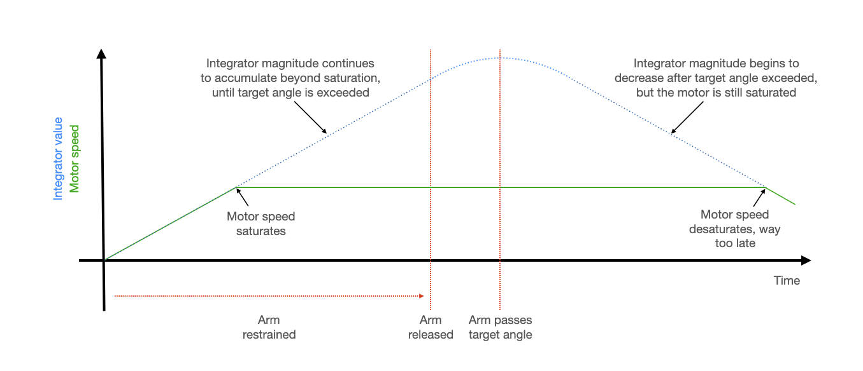
Figure 7. Integrator windup: the integrator keeps growing past saturation, so the motor stays saturated long after the arm passes the target. From the course PID notes.

2.6 PWM and the motor circuit
PWM. GPIO 4 is channel A of PWM slice 2. The slice's counter runs at f_{sys}/CLKDIV = 6 MHz and wraps after 6001 counts:
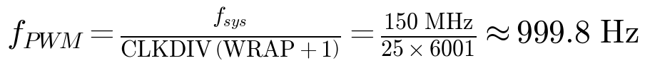
The duty cycle is the channel level divided by 6001, so the command has 6001 steps (0.017% each). The motor's electrical (L/R) and mechanical time constants are much longer than the 1 ms period, so it responds to the average voltage:
The low bandwidth of the 4N35 optoisolator is what keeps the PWM near 1 kHz: its phototransistor needs tens of microseconds to switch, so a much faster PWM would never fully turn the MOSFET on or off. The same wrap event drives our control interrupt, so the controller runs at exactly the PWM rate with no separate timer to keep in sync.
Why the motor needs protection. A motor's armature is an inductor. Switching off its current quickly produces a large voltage spike. The notes' example, 1 mH carrying 1 A switched off in 10 ns, gives
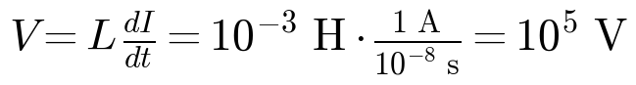
The 1N4001 flyback diode across the motor gives that current a safe path. The brushes also produce high-frequency noise (above 100 kHz), which the 0.1 µF ceramic capacitor shunts (electrolytics are too slow). Finally, the 4N35 isolates the Pico completely: the two sides share no ground, and only light crosses between them (Section 3.2).

2.7 Fixed-point arithmetic
All ISR math except atan2 is fixed point. fix15 is a signed 15.16 number in a 32-bit int (Figure 8): range ±32,768 with a resolution of 1/65,536 ≈ 1.5 × 10⁻⁵.
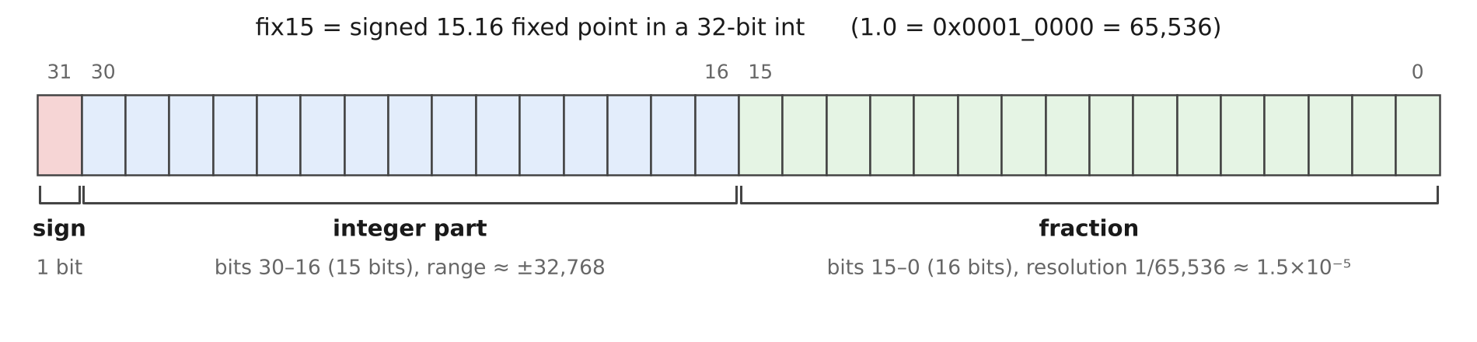
Figure 8. fix15 (15.16) bit layout used by mpu6050.h.
- Multiplication uses a 64-bit product then shifts right by 16. In the PID code we shift K_{p}·e right by 32 instead, which turns the product of two 15.16 numbers directly into an integer duty count.
- Sensor scaling (in mpu6050.c): at ±2 g the accelerometer gives 16,384 counts per g; shifting left by 2 gives 65,536 = 1.0 g. At ±250 °/s the gyro gives 131 counts per °/s; multfix15(raw, 500<<16) = raw × 500 / 65,536 ≈ raw / 131.
- Constants are pre-scaled and slightly rounded: 0.001 → 65 (really 0.000992) and 0.999 → 65,470. The gyro step is therefore about 0.8% short, and the PWM period is 1.0002 ms rather than 1 ms. The accelerometer path corrects both slowly, which is another reason the filter needs a little accelerometer weight.
Two bugs we hit came straight from mixing formats (Section 3.1): a stray set of 1.15 macros (1.0 = 32,768) read the driver's 15.16 data at half scale, and passing 180/M_PI as a fix15 argument truncated it to the integer 57. The fix was to use the header's oneeightyoverpi constant (3,754,936 = 57.2958 × 65,536).

2.8 I2C
I2C is a two-wire, open-drain bus: devices only ever pull SDA and SCL low, and pull-up resistors bring them high, so any device can hold the bus. Each byte is 8 data bits plus an acknowledge bit. A read of the MPU-6050 writes the start register address, then issues a repeated start (keeping control of the bus) and reads 6 bytes; the IMU auto-increments its register pointer. At 400 kHz:
So the I2C reads use about 40% of each control period, which is why the rest of the ISR is lean fixed-point code and all drawing runs on the other core. Open-drain also explains our worst hardware bug: if the Pico resets in the middle of a read, the still-powered IMU can be left holding SDA low and every later transfer hangs (Section 3.1).

3 Design and Testing Methods

3.1 Build order and debugging
We built and tested in stages, verifying each one on the VGA screen before closing the next loop: motor driver PCB and open-loop PWM (week 1); IMU, complementary filter, display and P control (week 2); D, I, the demo button and overcurrent protection (week 3). Most of our debugging time went to start-up hangs and sensor conventions rather than control code:
Symptom | Cause | Fix
Fan at full speed even at duty 0 after merging the PWM demo into the IMU demo | The program never reached the PWM setup: mpu6050_reset() uses blocking I2C writes and hung, leaving GPIO 4 floating | Found by noticing that VGA and serial were also dead; IMU wiring re-seated
VGA blank, serial dead, again with the wiring fine | Stuck I2C bus: the IMU held SDA low after a reset in mid-transfer. Reflashing doesn't clear it, a power cycle does | Bus recovery at start-up: clock SCL up to 9 times until the IMU releases SDA (main(), lines 568–586)
Angles wrong by 2× | Local 1.15 fixed-point macros overrode the driver's 15.16 macros | Removed the local macros
Angles off by a constant factor | 180/M_PI truncated to 57 when passed as fix15 | Use oneeightyoverpi
Angles read 80–300° and didn't track the arm | The filter used a_{y}, the rotation axis (always near 0), so atan2 flipped between ±90°; plus a leftover +π offset | Use a_{x}, a_{z} and gyro y; remove +π so horizontal = 0°
Complementary angle jumped the wrong way, then crept to the right value | Gyro sign opposite to the accelerometer's (the symptom described in lecture) | Add, rather than subtract, the gyro step
P-only arm settled about 10° low or bounced | P-only needs a non-zero error to hold the arm up; higher K_{p} oscillates | Add D (damping), then I (removes the offset)

Table 2. Main problems found during development. Appendix B has the full AI prompt log for these sessions.
Before closing the loop we checked the filter by hand with the motor off, tilting the arm and watching both angle traces on the VGA. This is how we caught the axis and sign problems in Table 2.

3.2 Motor driver circuit
As the handout requires, the driver is soldered on the course PCB rather than a breadboard (Figure 9). The motor runs from its own 5 V supply through an IRLB8721 logic-level N-MOSFET whose gate is driven at 12 V. The Pico never touches the motor side: GPIO 4 lights the 4N35's LED through 330 Ω, and the phototransistor switches the 12 V gate supply onto the MOSFET gate.
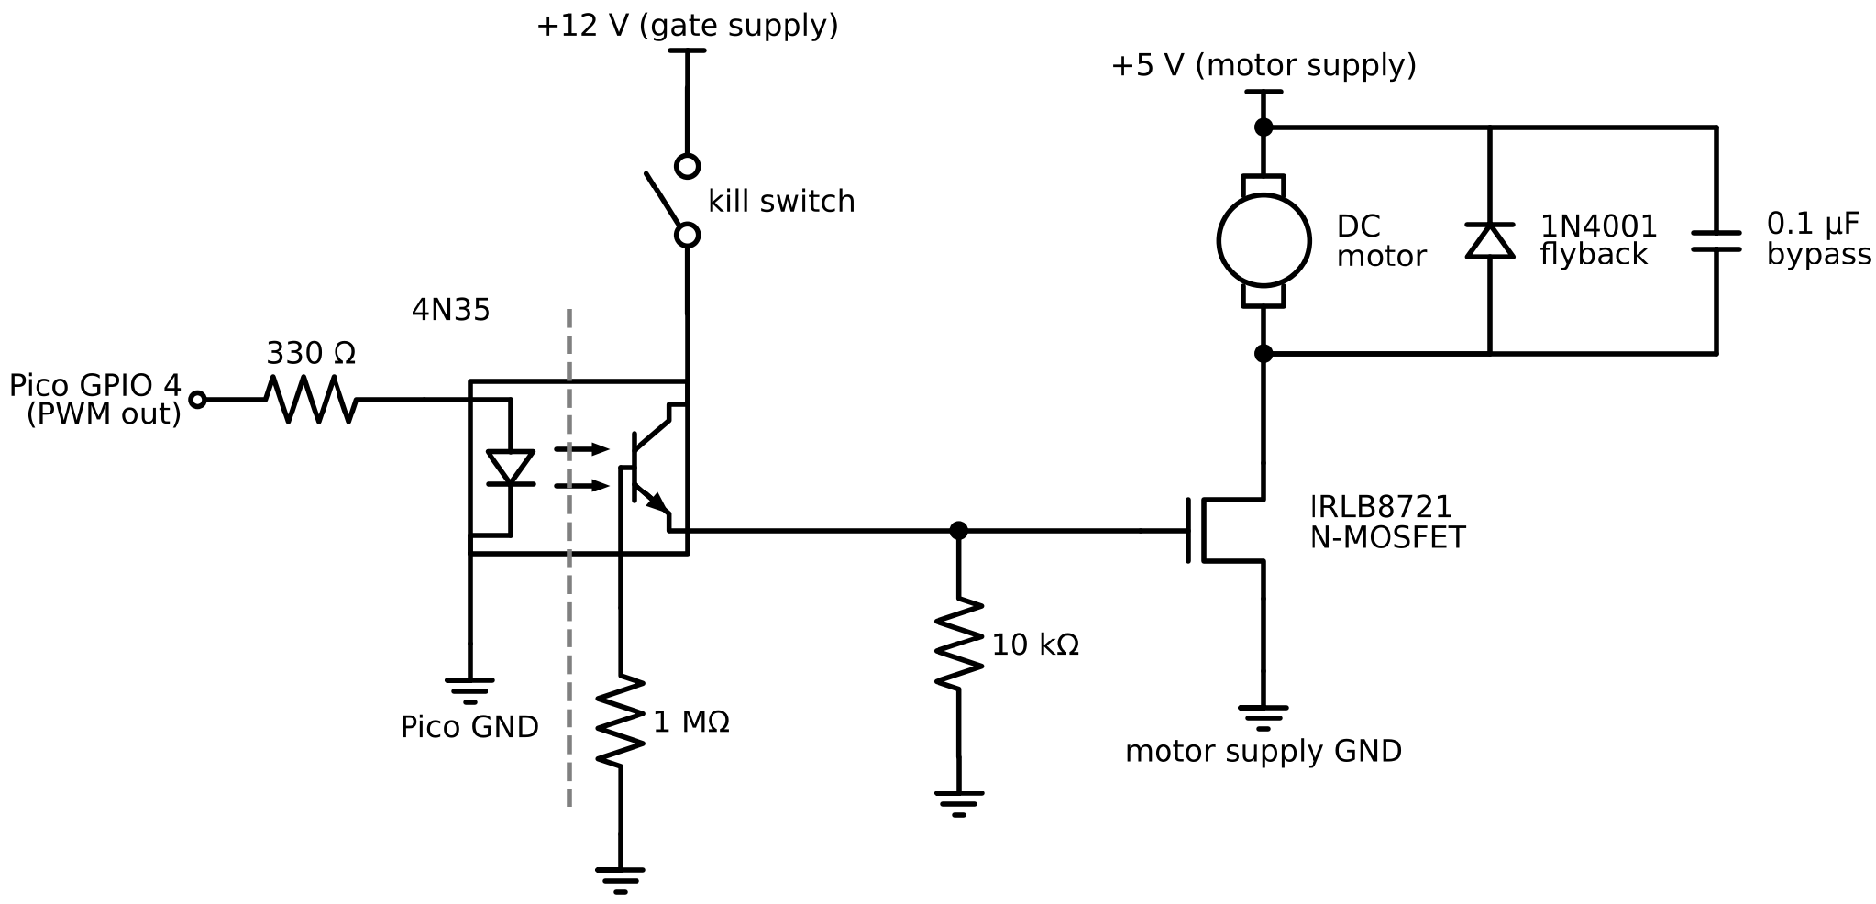
Figure 9. Motor driver schematic (as built on the course PCB). Only light crosses the 4N35; the Pico and motor sides have separate supplies and grounds.
- 4N35 optoisolator: when GPIO 4 is high the phototransistor conducts and pulls the gate toward 12 V, so the motor runs. When it is low, the 10 kΩ resistor pulls the gate to ground, so the MOSFET is off. This is the "extra 10 k" on the PCB the course page asks about: without it the gate would float and the motor could run on its own. The 1 MΩ base resistor drains the phototransistor's stored base charge, shortening its fall time.
- 1N4001 flyback diode across the motor catches the inductive spike of Section 2.6.
- 0.1 µF ceramic capacitor across the motor shunts brush noise.
We first drove the board with the course PWM demo and confirmed that the motor speed followed the duty cycle set from the serial terminal, before merging the PWM code into the IMU program (where the n command now sets a manual duty).

3.3 PWM configuration
GPIO 4 and 5 are assigned to PWM slice 2 (channel B on GPIO 5 is set to level 0 and unused). The slice wraps at WRAPVAL = 6000 with CLKDIV = 25, giving the 999.8 Hz of Section 2.6, and its wrap interrupt is registered as on_pwm_wrap(). The ISR only writes a new level with pwm_set_chan_level() when the command changes. DUTY_MAX is 6000 (100%). We used a 4500 cap during early tuning and raised it back to 6000 for the final version, which also adds the slew limit of Section 3.6.

3.4 MPU-6050 and I2C
The IMU is on I2C0 at 400 kHz (SDA GPIO 8, SCL GPIO 9) and is powered from the Pico's 3.3 V. The course driver sets it up as in Table 3. In the ISR, mpu6050_read_raw() uses I2C calls with 250 µs timeouts, so a glitch can cost one sample but can never hang the control loop. The one-time reset in main() still uses blocking writes, which is why the bus recovery runs first. After the reset, we seed the accelerometer filters and the complementary angle from the first reading, so the estimate starts at the true angle instead of creeping up from 0.
Register | Value | Effect
0x6B PWR_MGMT_1 | 0x00 | Wake from sleep
0x19 SMPLRT_DIV | 7 | 8 kHz / (1 + 7) = 1 kHz sample rate, matching the control rate
0x1B GYRO_CONFIG | 0x00 | ±250 °/s (131 LSB per °/s)
0x1C ACCEL_CONFIG | 0x00 | ±2 g (16,384 LSB per g)
0x37 / 0x38 | 0x10 / 0x01 | Data-ready interrupt enabled (pin not used; we poll from the PWM ISR)
0x3B / 0x43 | read 6 bytes each | Accelerometer x, y, z and gyro x, y, z, big-endian 16-bit

Table 3. MPU-6050 registers used by mpu6050.c.

3.5 The control ISR
Everything time-critical runs in on_pwm_wrap() on core 0, once per PWM period. Each call:
1. Clears the slice-2 interrupt flag and toggles GPIO 14 (a 500 Hz square wave on a scope, one edge per ISR).
2. Reads the IMU (accelerometer then gyro).
3. Low-passes a_{x} and a_{z} (shift by 4) and computes the accelerometer angle with atan2.
4. Updates the complementary filter with gyro y.
5. Debounces the demo button and steps the demo target (Section 3.7).
6. If closed loop is on, runs PID with conditional integration and the slew-limited clamp; otherwise clears the integrator.
7. Writes the PWM level if it changed.
8. Every 10th call (threshold), stores the angles and duty in 530-entry circular buffers for the display.
The controller core, verbatim from imu_demo.c (comments shortened):
angle_error = desired_angle - complementary_angle ; // + means arm is below target
long long p_term = ((long long)Kp) * ((long long)angle_error) ;
long long d_term = ((long long)Kd) * ((long long)gyro[1]) ; // de/dt = -gyro y
fix15 i_step = multfix15(Ki, angle_error) ;
int pd = (int)((p_term - d_term) >> 32) ; // 15.16 x 15.16 -> integer counts
int u_limit = control + DUTY_SLEW ; // overcurrent protection: slew limit
if (u_limit > DUTY_MAX) u_limit = DUTY_MAX ;
if (!(i_step > 0 && pd + fix2int15(i_term) >= u_limit)) i_term += i_step ; // conditional integration
if (i_term > int2fix15(i_max)) i_term = int2fix15(i_max) ;
if (i_term < 0) i_term = 0 ;
int u = pd + fix2int15(i_term) ;
if (u < 0) u = 0 ;
if (u > u_limit) u = u_limit ;
control = u ;
Positive error means the arm is below the target and needs more thrust. D is subtracted because de/dt = −ω_{y}: an arm rising fast gets less thrust, an arm falling fast gets more.

3.6 Overcurrent protection and anti-windup
A setpoint step makes the P term jump (80 × 90° = 7200 counts on release from hanging). Stepping a stalled motor from 0 to full voltage draws a large inrush current, because there is no back-EMF yet to limit it (I = V/R at ω = 0). The final code therefore lets the command rise by at most DUTY_SLEW = 20 counts per 1 ms sample. Decreases are not limited, so the controller can still cut thrust instantly.
The ramp is visible in every step of Section 5.2 as a dotted vertical line in the duty trace: one plotted point every 10 ms is a 200-count jump. 300 ms is short next to the arm's ~1 s response, so it costs little speed.
The slew limit creates a new windup risk: while the output is pinned at the ramp ceiling, the error stays large and the integrator would keep charging. So integration is conditional: a positive I step is skipped whenever P + D + I is already at or above u_limit. This is the clamping rule from the course PID notes (stop integrating when the output is saturated and the error would push it further). Because of this, we left i_max at 10000, above DUTY_MAX, so the hard cap never binds in practice. The I term is also floored at 0, since a negative integral could only delay thrust when the arm needs it.

3.7 Demo button sequence
The button is on GPIO 15, wired to ground with the internal pull-up (pressed = low). The ISR polls it every 1 ms and accepts a new state only after it has disagreed with the old one for 20 consecutive samples (20 ms debounce). Since one ISR call is 1 ms, the sequence is timed by counting calls:
Time | Target and controller state
Button held | Closed loop off, duty 0, integrator cleared, target −90°: the arm hangs straight down
Release, t = 0 | Closed loop on, target 0° (horizontal)
t = 5 s | Target +30°
t = 10 s | Target −30°
t = 15 s | Target 0°; the sequence ends and the controller keeps holding horizontal

Table 4. Demo sequence, run with whatever gains are currently loaded. No reset is needed.
The target is written only at the four step times, so a serial a command can still override it in between.

3.8 VGA display
The Pico drives the monitor through the adapter PCB we soldered in Lab 2 (Figure 10): each colour bit passes through a series resistor, forming a simple resistor DAC with the monitor's 75 Ω input. We reused the course's double-buffered VGA driver (Figure 11): three PIO state machines generate hsync, vsync and the 4-bit colour output, and a DMA chain streams pixel data to them. At each vsync the chain swaps buffers and sets a flag, giving the drawing thread about 16.7 ms per frame. A frame is 640 × 480 × 4 bits (two pixels per byte, 320 bytes per row), so the two buffers use about 300 kB of the RP2350's 520 kB SRAM.
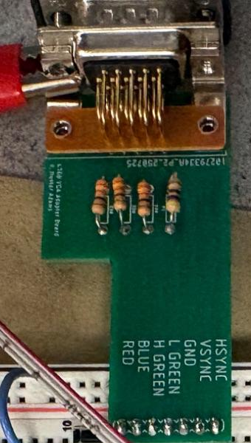  Figure 10. Our VGA adapter PCB (photographed during Lab 2). | 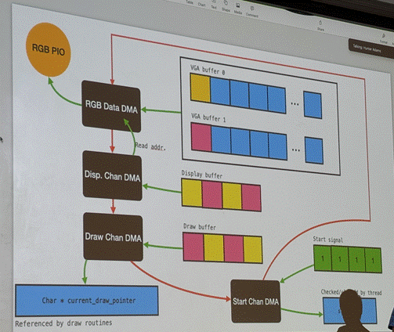  Figure 11. The VGA driver's DMA chain, from lecture.
Core 1 runs only the drawing thread, so drawing can never delay the control ISR. Each frame it redraws:
- Top plot: complementary angle (yellow) and target line (light blue), −90° to +90° over 150 pixels (1.2° per pixel).
- Bottom plot: the controller's motor command control (orange/yellow), 0–6000 counts over 150 pixels (40 counts per pixel).
- Text: accelerometer and complementary angles, target, K_{p}, K_{d}, duty, mode, K_{i}, I max and the live I term.
With one stored point per 10 ms, the 530-pixel plot spans 5.3 s; the serial t command changes this. The plotted command is the controller output itself, sampled every 10 ms, not a separately low-pass-filtered copy. With K_{d} = 12 and the slew limit, the trace was smooth enough to read its shape clearly (Section 5.2). The course Display page's filter, motor_disp += (control − motor_disp) >> 4, is the same IIR as our accelerometer filter and would be a one-line addition (Section 6).

3.9 Serial interface
The serial thread on core 0 waits (without blocking the ISR) for a one-letter command, prompts for a value, range-checks it and writes it straight into the volatile globals the ISR reads, so it takes effect on the next 1 ms cycle.
Cmd | Sets | Units / range
a | Target angle | −90 to +90° (0 = horizontal)
p | K_{p} | duty counts per degree, 0–6000
i | K_{i} | duty counts per degree per ms, 0–100 (0 also clears the integrator)
d | K_{d} | duty counts per °/s, 0–6000
m | Integrator cap i_max | 0–6000 duty counts
c | Closed loop on / off | 1 / 0 (0 also turns the motor off)
n | Manual duty cycle (turns closed loop off) | 0–6000
t | Plot timestep | ISR samples per plotted point (default 10)

Table 5. Serial commands.

3.10 Wiring and system overview
Signal | RP2350 pin | Notes
VGA Hsync / Vsync | GPIO 16 / 17 | PIO state machines
VGA Green lo / Green hi / Blue / Red | GPIO 18 / 19 / 20 / 21 | 470 Ω / 330 Ω / 330 Ω / 330 Ω
MPU-6050 SDA / SCL | GPIO 8 / 9 | I2C0, 400 kHz; IMU powered from 3.3 V
Motor PWM | GPIO 4 | Slice 2 channel A, to the 4N35 through 330 Ω
(PWM slice 2 B) | GPIO 5 | Configured, level 0, unused
ISR timing | GPIO 14 | Toggles every ISR (scope)
Demo button | GPIO 15 | To GND, internal pull-up, 20 ms debounce

Table 6. RP2350 wiring connections.
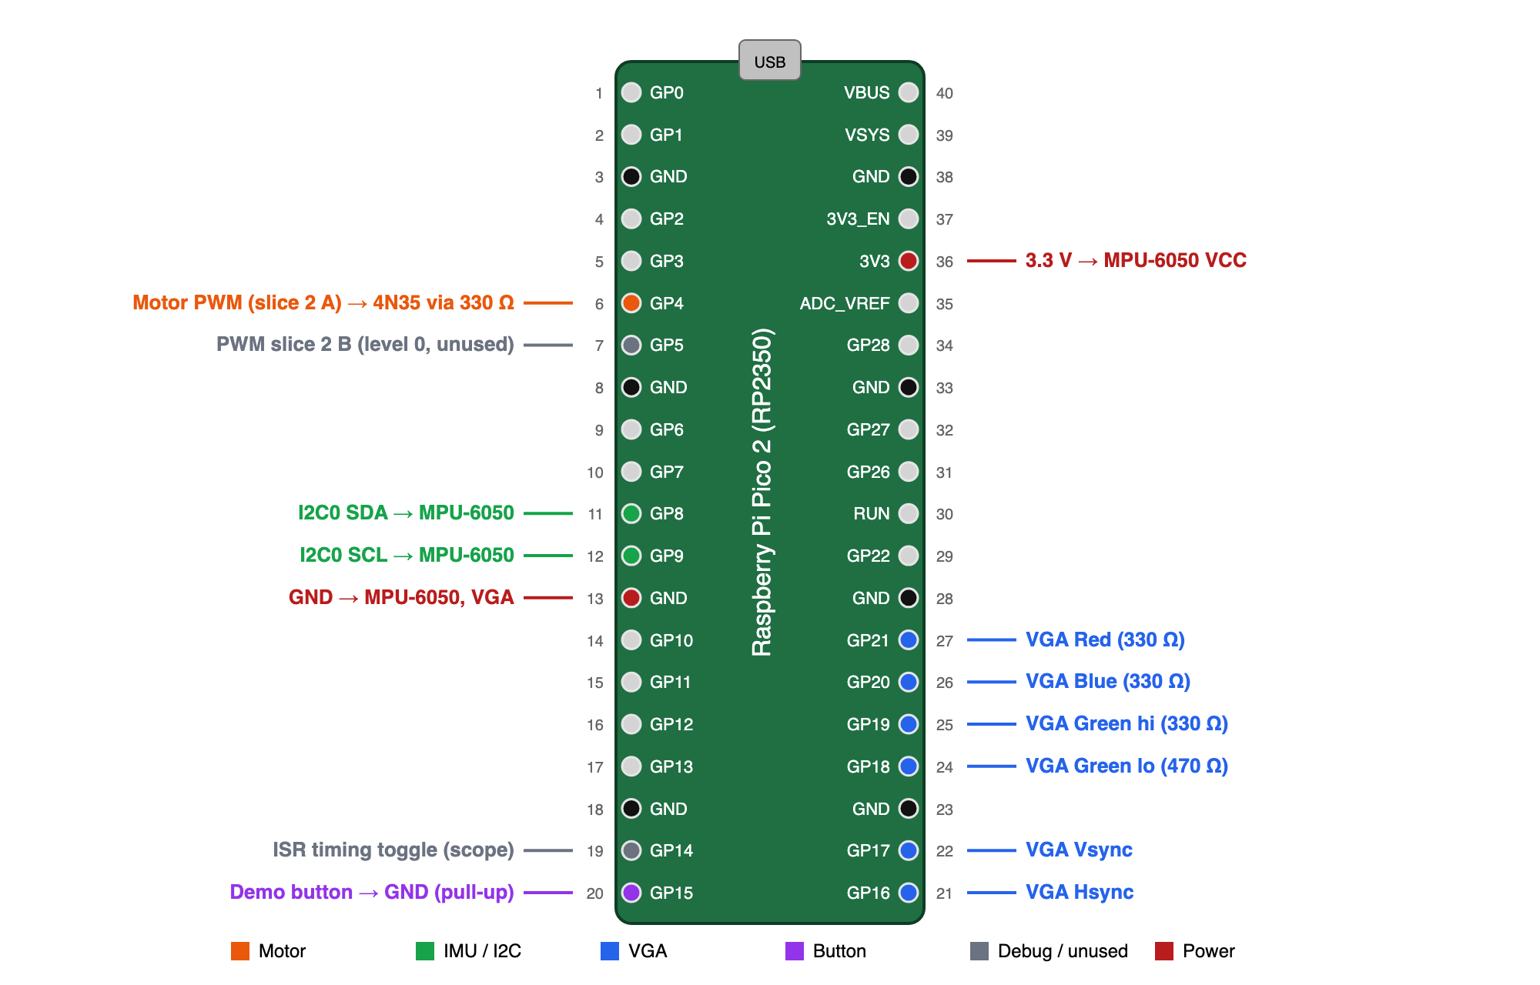
Figure 12. Pico 2 pinout with our pin assignments, coloured by subsystem.
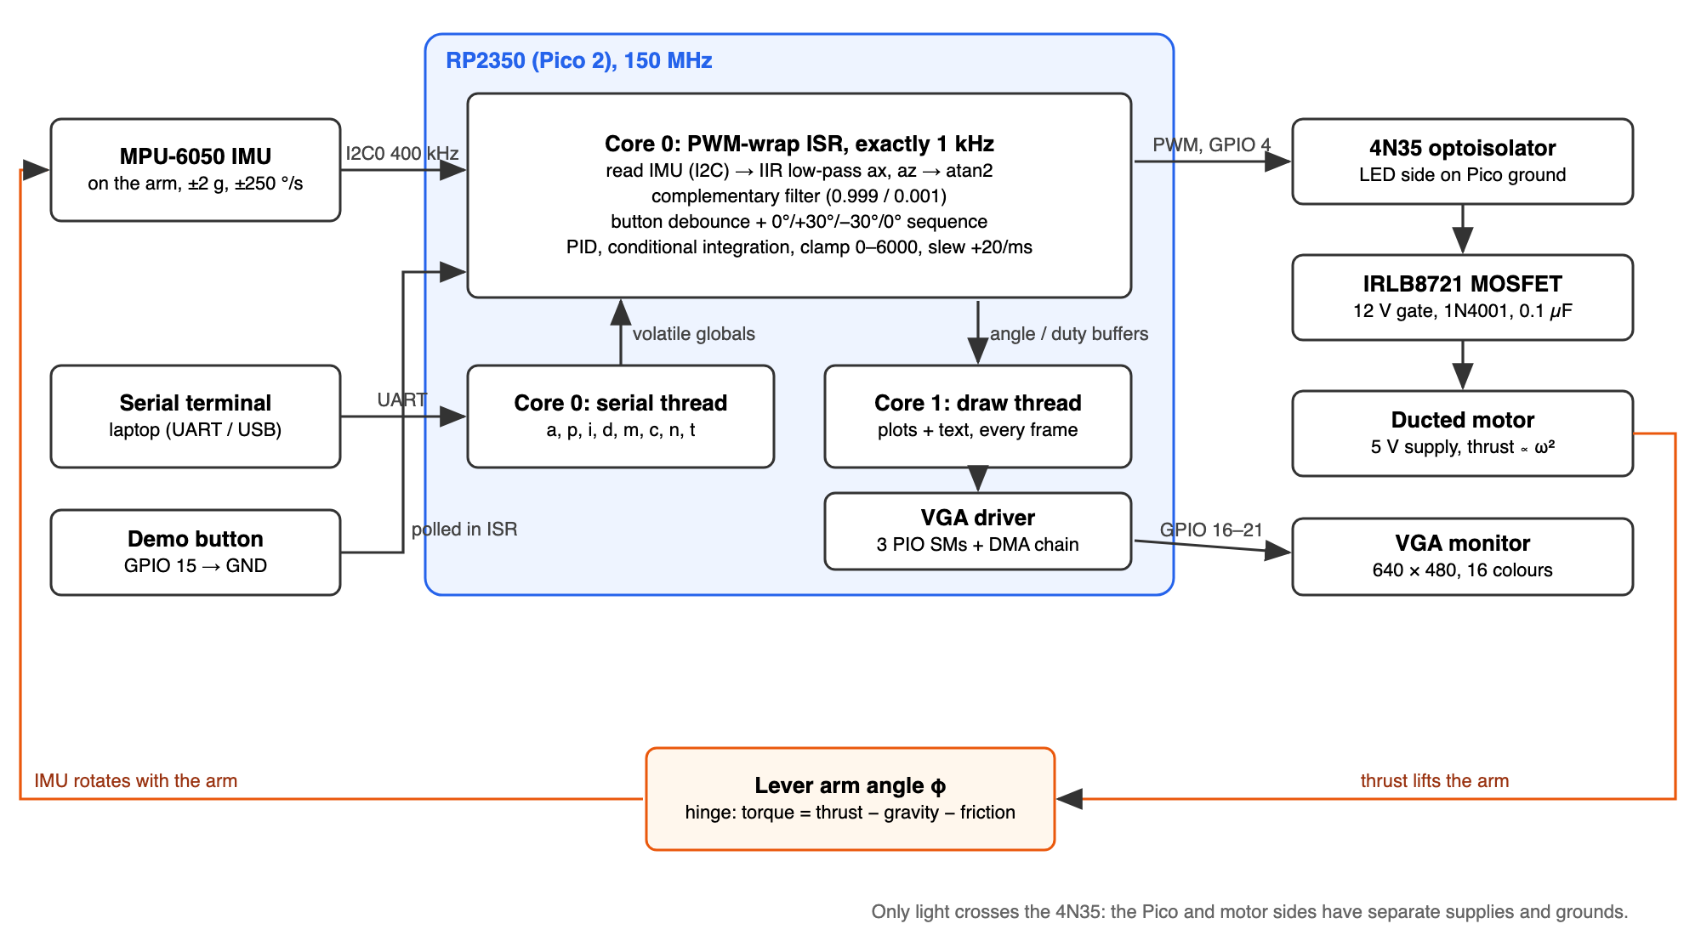
Figure 13. System block diagram. Core 0 closes the loop at 1 kHz and runs the serial thread; core 1 only draws. The orange path is the physical feedback through the arm.

4 Documentation
Where to find the drawings, listings and data the course policy asks for:
Item | Where
Motor circuit schematic | Figure 9, Section 3.2
System block diagram | Figure 13
Pinout and wiring | Figure 12, Table 6
Complementary filter | Figure 2, Figure 3, Section 2.2
IMU registers, serial commands, demo timing | Table 3, Table 5, Table 4
VGA adapter and driver | Figure 10, Figure 11
Rig photos | Figure 1 and the photos in Figure 14–Figure 17
VGA screen dumps (demo sequence) | Figure 14–Figure 17; earlier runs in Figure 18, Figure 19
Settling times, hover duties | Table 8, Table 9
Commented code listing | Appendix A
AI prompt log | Appendix B

Table 7. Documentation index.

5 Results

5.1 Final gains
K_{p} = 80 counts/°, K_{i} = 0.2 counts/(°·ms), K_{d} = 12 counts/(°/s), i_max = 10000 (non-binding; conditional integration handles windup), output 0–6000 with a +20 counts/ms slew limit. One set of gains ran the whole demo sequence without a reset; Section 7 (Q3) explains how we chose them.

5.2 Demo sequence
Figure 14–Figure 17 show the four steps of the button demo, taken from our video of the checked-off run. Each VGA screen (left) is paired with a photo of the arm holding that angle (right). In every screen, the top plot is the complementary angle (yellow) against the target (blue), the bottom plot is the motor command on a 0–6000 scale, and the newest data is at the right.
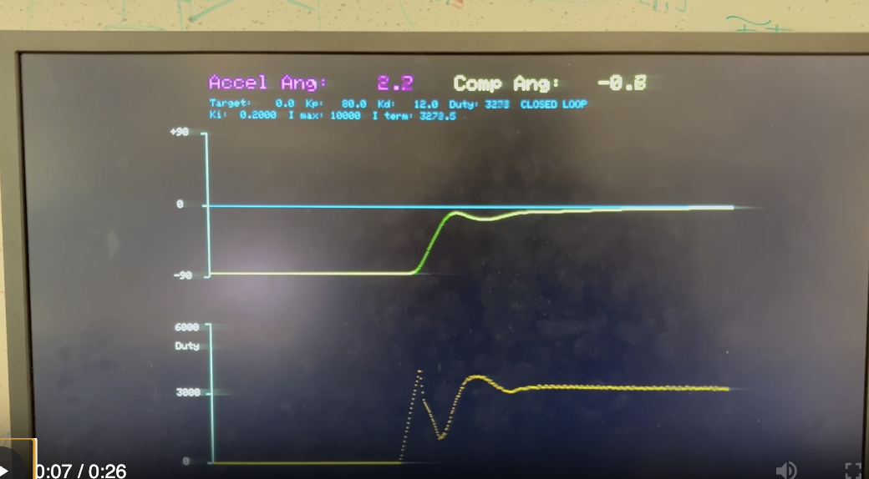 | 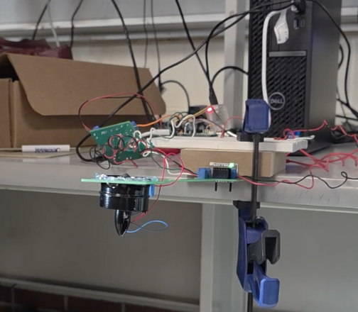
Figure 14. t = 0: release, −90° → 0°. The duty starts at 0 (motor off while held), ramps up at the slew limit (dotted rise) to about 4100, dips to about 1300 as D brakes the rising arm, then settles at 3278. The arm comes up from below with no overshoot, and the integrator, which started from 0, pulls in the last few degrees. Readout at the right edge: target 0.0, complementary angle −0.8°, duty 3278, I term 3278.5. At rest the I term supplies essentially all of the command, as Section 2.4 predicts. Right: the arm holding horizontal (seen edge-on), with the duct hanging below the arm.
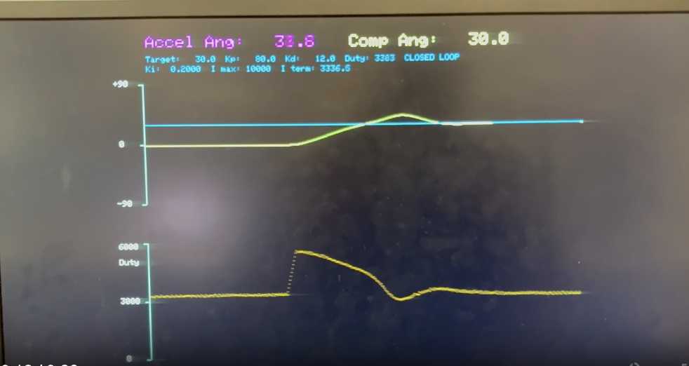
Figure 15. t = 5 s: 0° → +30°. The P kick (80 × 30° = 2400 counts on top of the 3280-count hover command) ramps the duty to about 5800. The arm overshoots to about +46° and the duty dips to about 3100 while the extra integral built up during the rise unwinds, then it settles at +30.0° with duty 3383 and I term 3336.5. Right: the arm at +30°.
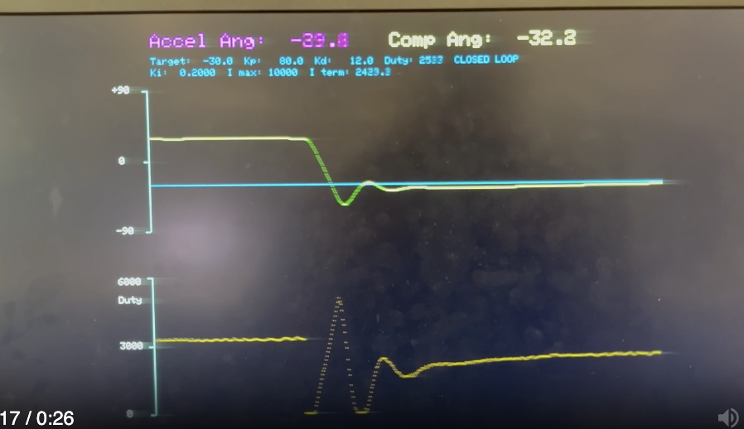 | 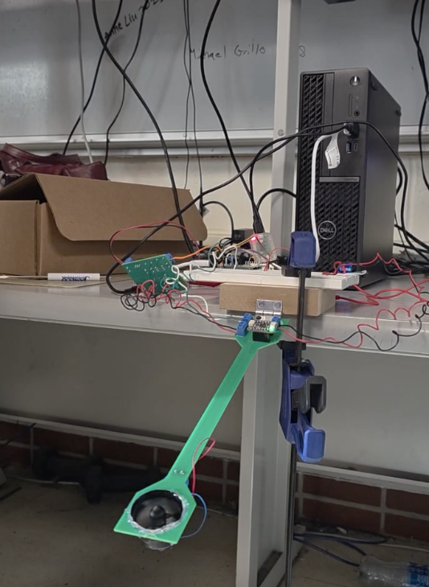
Figure 16. t = 10 s: +30° → −30°. The command drops straight to 0, because decreases are not slew-limited and the motor cannot pull down, so gravity drives the fall. The arm passes the target falling fast, and P and D call for a burst of about 5000 counts to catch it. The arm still undershoots to about −56°, rebounds, and the duty hits 0 a second time before settling. The I term lost much of its stored value during the fall, so the final approach is a slow creep: the duty is still rising (2533, I term 2433.9) with the arm at −32.8°. Right: the arm at −30°.
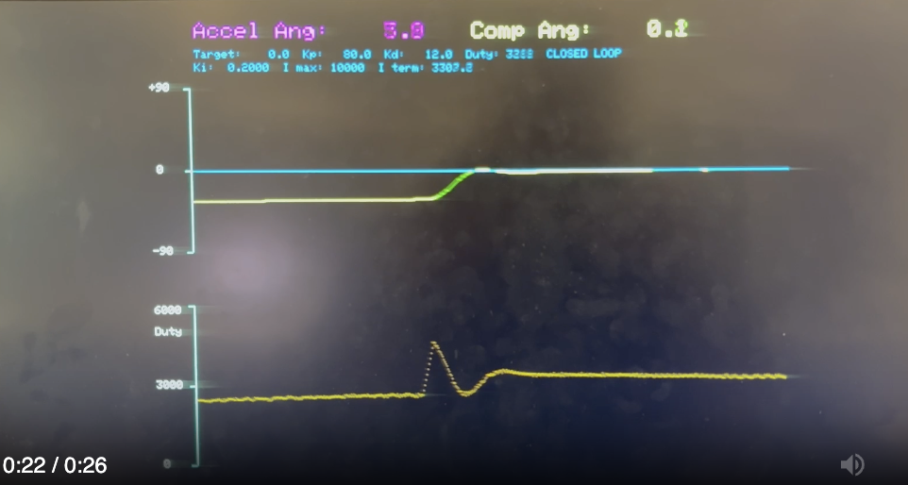
Figure 17. t = 15 s: −30° → 0°. The fastest step. The integrator is already near the hover value, so a short P kick (duty about 4700) lifts the arm with only about 4° of overshoot, and it settles at 0.2° with duty 3288 and I term 3307.2. Right: the arm back at horizontal (same pose as Figure 14).

5.3 Settling times
Step | Settling time (s) | Peak overshoot (from screen) | Main limit on the response
−90° → 0° | 2.74 | none (approaches from below) | Integrator starts at 0 and must build the hover command
0° → +30° | 2.38 | ≈ 16° (peak ≈ +46°) | Integral charged during the rise has to unwind
+30° → −30° | 3.56 | ≈ 26° (low ≈ −56°) | Gravity-driven fall (motor can't pull down); I partly unwound and rebuilds slowly
−30° → 0° | 0.98 | ≈ 4° | Integrator already close to the hover value

Table 8. Settling times measured from our recording of the demo run. Overshoot was read off the VGA photos (1.2° per screen pixel, so about ±3°).
The pattern matches the physics of Sections 2.3–2.6. Upward steps are pushed by the motor and braked by gravity and D, so they are well controlled. The downward step is driven by gravity and can only be braked by thrust, which has to ramp back up from zero, so it overshoots most and settles slowest. In every step the integrator's state going in decides the tail: it is the term that has to change by the difference in hover command between the two angles.

5.4 Hover duty vs. angle
At rest P ≈ 0 and D ≈ 0, so the steady duty measures the thrust needed to hold each angle.
Angle | Duty (I term) | Duty as % of period | (duty / duty_{0°})² ≈ thrust ratio | Point-mass model cos φ
0° | 3278 (3279) | 54.6% | 1.00 | 1.00
+30° | 3383 (3337) | 56.4% | 1.07 | 0.87
−30° | 2533 (2434), still rising | 42.2% | ≤ 0.60 | 0.87

Table 9. Steady duty at each demo angle, read from the VGA readouts. The thrust ratio assumes thrust ∝ ω² with ω roughly proportional to the average motor voltage.
A symmetric point-mass arm would need the same thrust at ±30°, 13% less than at horizontal. Ours needs more at +30° and much less at −30°. This is the centre-of-mass offset of Section 2.3: with the duct hanging below the arm, the gravity torque is proportional to r cos φ + d sin φ. Fitting the two ratios gives d/r ≈ 0.4–0.5. That is only a rough estimate, since the −30° duty was still creeping up and thrust is only approximately ∝ duty², but the direction of the asymmetry is clear. It also means the arm's passive balance point is not exactly at horizontal: by the same model, gravity stops being restoring around φ ≈ arctan(d/r), roughly 20–30° above horizontal.

5.5 Stable range
With the final gains the arm was stable from −90° (hanging; the controller simply turns the motor off) up to about +50°. The upper limit varied with which 5 V motor supply we used; above it the arm was no longer stable with these gains (details in Section 7, Q4).

5.6 Earlier tuning runs
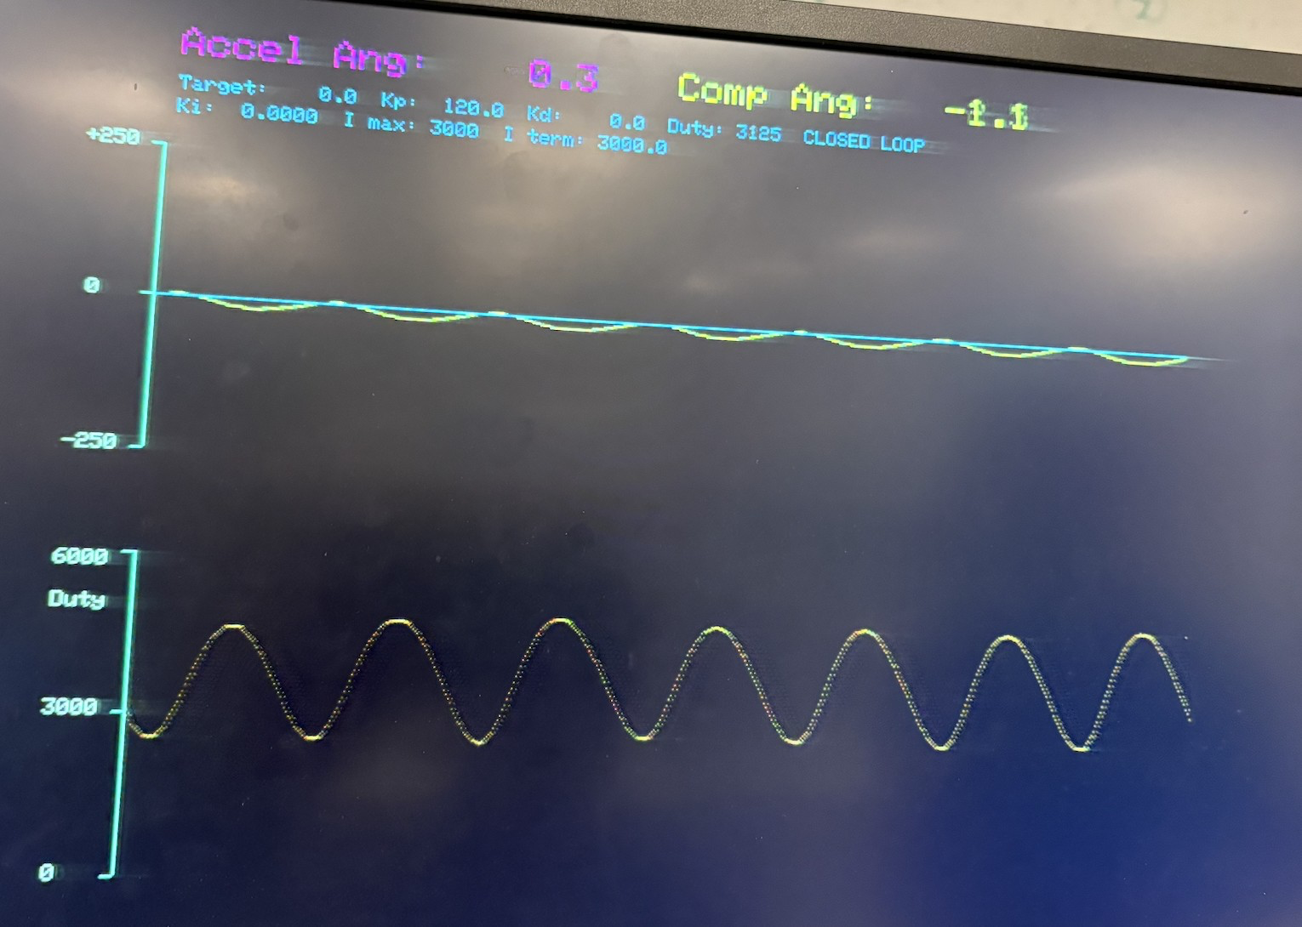  Figure 18. Early P-only test (K_{p} = 120, K_{i} = K_{d} = 0, target 0°), on an older build with a ±250 angle axis. The arm oscillates steadily, about 6.5 cycles in 5.3 s (≈ 1.2 Hz): the edge of stability. The I term was still 3000 from an earlier run, because at that time setting K_{i} = 0 did not clear it. The final code clears the I term when K_{i} is set to 0. | 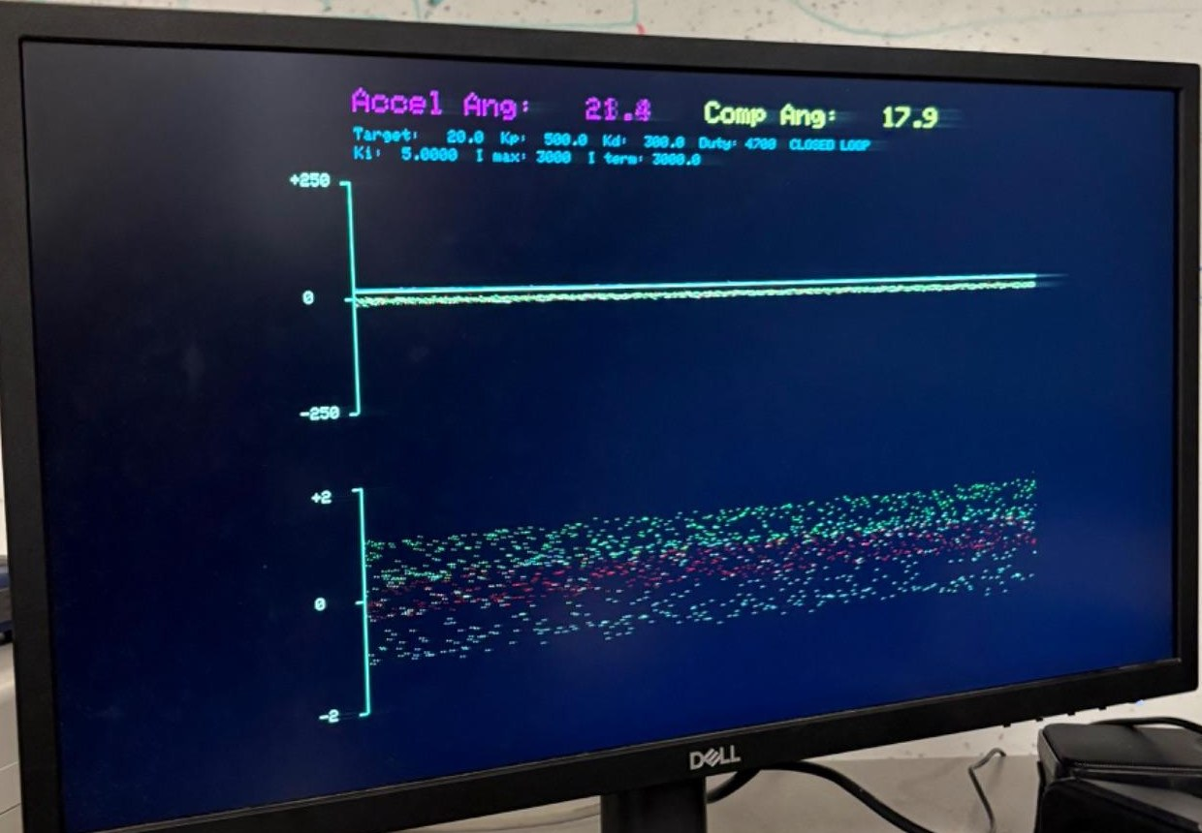  Figure 19. Early build with much larger gains (K_{p} = 500, K_{d} = 300, K_{i} = 5). The bottom plot still showed the raw accelerometer axes (±2 g): with the motor running they are spread across most of the range by vibration, while the complementary angle in the top plot is a clean line. This is the motivation for the complementary filter in one picture.

6 Conclusion
Our helicopter met the lab requirements. The arm ran the full 0° / +30° / −30° / 0° demo on one set of gains without a reset. Every step settled within 3.6 s, gains and target could be changed from the serial terminal at any time, and the VGA showed the angle, target and motor command live. The results also lined up with the theory. The complementary filter's 1 s crossover kept vibration out of the estimate. The steady integral equalled the hover duty, as PID theory predicts. The asymmetric settling and hover duties are what the one-directional actuator and the arm's offset centre of mass predict.
We learned how to fuse two imperfect sensors, how each PID term shapes the response, and why a motor needs isolation, a flyback diode and a bypass capacitor. Most of our debugging went to the I2C start-up hang and to fixed-point and axis conventions, not to the controller.
What we would change.
- Plot a low-passed copy of the command (motor_disp, the course Display page's IIR) as the handout asks, rather than the sampled raw command.
- Calibrate the gyro bias at start-up (average a second of readings with the arm still), removing the τ·b offset of Section 2.2.
- Add a feed-forward hover command based on the r cos φ + d sin φ model, so the integrator only trims the remaining error. This should shorten the slow tails, especially after downward steps.
- Move the printf on button events out of the ISR. Printing inside the 1 kHz interrupt can stretch one control period.
- Measure the arm length and mass so the plant model can be checked quantitatively.

7 Answers to the Lab Report Questions
The helicopter handout asks the report to include the following. Each answer is self-contained and points to the supporting figures and tables.

Q1. A schematic of the circuit you built
See Figure 9, with the wiring in Table 6, Figure 12 and Figure 13. GPIO 4 (PWM) drives the 4N35's LED through 330 Ω. Its phototransistor switches the 12 V gate supply (through a kill switch) onto the gate of the IRLB8721 MOSFET, with a 10 kΩ gate pull-down and a 1 MΩ base resistor for a fast fall time. The motor runs from a separate 5 V supply with a 1N4001 flyback diode and a 0.1 µF ceramic capacitor across it. The Pico and motor sides share no ground. The IMU (I2C0, GPIO 8/9), VGA (GPIO 16–21) and demo button (GPIO 15) connect to the Pico as in Table 6.

Q2. VGA screen dumps of (1) motor control and (2) actual angle, including the four-angle demo
See Figure 14–Figure 17, one per step of the demo (0°, +30°, −30°, 0°), each paired with a photo of the arm at that angle. In each, the top trace is the measured angle against the target and the bottom trace is the motor command (0–6000). While the button is held the command is 0 and the arm hangs at −90° (left edge of Figure 14). Every step shows the slew-limited ramp in the command, and the settled command matches the integrator, as described in the captions.

Q3. How you selected the three PID gains
Starting values from units. We sized each gain so its term gives a sensible duty count:
- K_{p}: a 90° error (hanging, target horizontal) should call for roughly full duty, so K_{p} ≈ 6000/90 ≈ 67, i.e. tens.
- K_{d}: the gyro rate in °/s is the same order of magnitude as the error in degrees, so K_{d} is also tens. (The course page's "thousands" assumes differencing noisy ADC samples, not a gyro.)
- K_{i}: the integrator adds K_{i}·e a thousand times a second, so K_{i} must be orders of magnitude smaller; we started near 1/32.
Tuning procedure (the order from lecture and the PID notes), with what we looked for at each stage:
1. P only: raise K_{p} to find the edge between stability (oscillations die out and the arm settles) and instability (oscillations grow into large swings). K_{p} = 120 gave steady oscillation at about 1.2 Hz (Figure 18), so we backed off to K_{p} = 80, about two-thirds of that.
2. Add D until the oscillation stops. Our test: push the arm down below the target and let go. It should spring back up, overshoot once and quickly settle to a stable position. We ended at K_{d} = 12.
3. Add I to remove the steady-state error that P and D leave and bring the arm onto the target. Raising K_{i} reaches the target faster, but too much causes overshoot and slow, rolling oscillation (the integrator's 90° of phase lag). We settled on K_{i} = 0.2 (T_{i} = K_{p}/K_{i} = 0.4 s). At that rate a 5° error grows the I term by 1000 counts per second, so it can build the roughly 3300-count hover command within a few seconds.
4. Check the whole demo with the button and adjust. Conditional integration (Section 3.6) handled windup, so we left i_max at 10000.
The live I-term readout on the VGA (Section 3.8) was the most useful tuning aid: at every steady angle it should equal the duty, which confirms that P and D have done their job and only the integral is holding the arm up (Figure 14–Figure 17).

Q4. What are the maximum/minimum angles that produce stable behaviour for your PID gains?
Maximum ≈ +50°; minimum −90° (0° = horizontal). The maximum depended on which 5 V motor supply we used. Why the range is limited:
- Minimum. −90° is the hanging rest position. For targets near it the required thrust goes to zero, the controller output clamps at 0 and gravity holds the arm, so it is trivially stable. The serial interface accepts targets down to −90°.
- Maximum. Above the arm's balance point (horizontal for a point mass, somewhat higher for ours, Section 5.4), gravity's stiffness is negative: tipping further up reduces the restoring gravity torque, so the controller must supply all of the stability. The further above that point, the stronger this destabilising term (it grows like the sine of the distance past the balance point), until the margin that K_{d} provides runs out.
- Operating-point dependence. The plant gain 2K_{T}ω₀/(mL) changes with angle, and one fixed set of gains was tuned for the demo range around horizontal.
- Supply dependence. A different supply changes thrust per duty count (thrust ∝ V²), which scales the whole loop gain. The same gains then sit closer to or further from the stability edge, so the maximum angle moved.

Q5. What are the settling times at different angles?
Step | Settling time | Overshoot
−90° → 0° (release) | 2.74 s | none
0° → +30° | 2.38 s | ≈ 16°
+30° → −30° | 3.56 s | ≈ 26°
−30° → 0° | 0.98 s | ≈ 4°

(Same data as Table 8.) Upward steps settle in about 1–2.7 s. The downward step is slowest (3.56 s) because the motor can only cut thrust: gravity drives the fall, the arm undershoots, and the integrator has to rebuild. The fastest step (−30° → 0°, 0.98 s) started with the integrator already close to the hover value. The slowest upward step (release from −90°) started with the integrator at zero.

Q6. A heavily commented listing of your code
Appendix A lists imu_demo.c, mpu6050.c, mpu6050.h and CMakeLists.txt exactly as built and demonstrated. The course VGA driver and protothreads header were used unchanged and are not listed. Every change from the course MPU-6050 demo is marked in the comments (ADDED, CHANGED, FIXED, REMOVED), and those sections are shaded in the listing. Sections 2–3 explain the code's math and structure.

Q7. A prompt log from any AI tool used for code generation
Appendix B is the full log of our code-generation sessions with Claude Code (model: Claude Opus 5.5). It has 18 prompts from Oct 21–22, 2026, with our prompts verbatim and Claude's responses. Totals: 401 prompt words and 1719 logged response words exchanged; 214 lines of code given. Suggested additions / deletions / modifications: 36 / 1 / 22. Accepted, meaning still in the final code: 29 / 1 / 19.

8 Work Distribution and AI Use
Amber, Ivan, and Zarif worked together on all parts of the lab. We frequently met outside of our lab sections, and most of our work was done in person in the lab. Outside of the lab, we communicated frequently to ensure that we were all aware of the progress that had been made and what the immediate next steps were.
AI use. We used Claude Code (Claude Opus 5.5) while writing the program. Every prompt and response is in Appendix B, and the code it contributed is marked with ADDED / CHANGED / FIXED comments (shaded in Appendix A). We also used Claude to help organise, typeset and edit this report from our notes, draft report, photos, screenshots and measurements. Its code suggestions during report writing (a low-passed display variable, an alternative button routine on GPIO 2 and extra comments) were not merged into our program. All measurements, photos, screenshots and the hardware are ours.

References
1. V. H. Adams, PID control of a 1D helicopter (lab handout). https://vanhunteradams.com/Pico/Helicopter/Helicopter.html
2. V. H. Adams, Complementary filters. https://vanhunteradams.com/Pico/ReactionWheel/Complementary_Filters.html
3. V. H. Adams, Phenomenological introduction to PID controllers. https://vanhunteradams.com/PID/PID.html
4. V. H. Adams, Analytical introduction to PID controllers. https://vanhunteradams.com/PID/PID_Analytical.html
5. V. H. Adams, DC motor circuit and PWM. https://vanhunteradams.com/Pico/Helicopter/MotorCircuit.html
6. V. H. Adams, Data display. https://vanhunteradams.com/Pico/Helicopter/Display.html
7. V. H. Adams, Inter-Integrated Circuit (I2C). https://vanhunteradams.com/Protocols/I2C/I2C.html
8. V. H. Adams, MPU6050 IMU demo and PWM demo code. https://github.com/vha3/Hunter-Adams-RP2040-Demos
9. Raspberry Pi Ltd., RP2350 Datasheet (PWM and I2C chapters).
10. InvenSense, MPU-6000/MPU-6050 Register Map and Descriptions.
11. B. Land, ECE 4760/5730 course policy (lab report sections). https://people.ece.cornell.edu/land/courses/ece4760/EE4760_policy.html

Appendix A Commented Code Listing
These are the files exactly as built and demonstrated (Pico 2 / RP2350, Pico SDK 2.3.1). The program also uses the course's VGA/vga16_graphics_v3.c/.h, the three VGA PIO programs and pt_cornell_rp2040_v1_4.h, unchanged. Changes from the course MPU-6050 demo are marked in the comments with ADDED, CHANGED, FIXED or REMOVED; these are the sections written with AI assistance (Appendix B) and later edited by us. marks those lines. Comments are green.

A.1 imu_demo.c (main program: ISR, controller, display, serial)
1 /**
2 * V. Hunter Adams (vha3@cornell.edu)
3 *
4 * This demonstration utilizes the MPU6050.
5 * It gathers raw accelerometer/gyro measurements, scales
6 * them, and plots them to the VGA display. The top plot
7 * shows the target and actual (complementary) angle, bottom
8 * plot shows the fan duty cycle (PID output).
9 * CHANGED: top plot was gyro, bottom plot was accelerometer.
10 *
11 * HARDWARE CONNECTIONS
12 * - GPIO 16 ---> VGA Hsync
13 * - GPIO 17 ---> VGA Vsync
14 * - GPIO 18 ---> 470 ohm resistor ---> VGA Green
15 * - GPIO 19 ---> 330 ohm resistor ---> VGA Green
16 * - GPIO 20 ---> 330 ohm resistor ---> VGA Blue
17 * - GPIO 21 ---> 330 ohm resistor ---> VGA Red
18 * - RP2040 GND ---> VGA GND
19 * - GPIO 8 ---> MPU6050 SDA
20 * - GPIO 9 ---> MPU6050 SCL
21 * - 3.3v ---> MPU6050 VCC
22 * - RP2040 GND ---> MPU6050 GND
23 * - GPIO 4 ---> PWM_OUT
24 * - GPIO 15 ---> pushbutton ---> GND (internal pull-up)
25 */
26
27
28 // Include standard libraries
29 #include <stdio.h>
30 #include <stdlib.h>
31 #include <math.h>
32 #include <string.h>
33 // Include PICO libraries
34 #include "pico/stdlib.h"
35 #include "pico/multicore.h"
36 // Include hardware libraries
37 #include "hardware/pwm.h"
38 #include "hardware/dma.h"
39 #include "hardware/irq.h"
40 #include "hardware/adc.h"
41 #include "hardware/pio.h"
42 #include "hardware/i2c.h"
43 #include "hardware/clocks.h"
44 #include "hardware/sync.h"
45 // Include custom libraries
46 #include "VGA/vga16_graphics_v3.h"
47 #include "mpu6050.h"
48 #include "pt_cornell_rp2040_v1_4.h"
49
50 // We will start drawing at column 81
51 #define LEFT_EDGE 81
52
53 // Rescale the measurements for display
54 #define OLD_RANGE 500. // (+/- 250)
55 #define NEW_RANGE 150. // (looks nice on VGA)
56 #define OLD_MIN -250.
57 #define OLD_MAX 250.
58 #define ACCEL_SCALE 120.0
59
60 // Angle plot range (degrees)
61 #define ANGLE_MIN -90.
62 #define ANGLE_RANGE 180. // (+/- 90)
63 #define RAD2DEG 57.2957795f
64
65 // Place the plots
66 #define TOP_PLOT_BOTTOM 230
67 #define BOTTOM_PLOT_BOTTOM 430
68 #define PLOT_WIDTH 530
69
70 // Arrays in which raw measurements will be stored
71 fix15 acceleration[3], gyro[3];
72
73 // Arrays for circular display buffer
74 fix15 ax[PLOT_WIDTH] ;
75 fix15 ay[PLOT_WIDTH] ;
76 fix15 az[PLOT_WIDTH] ;
77 fix15 gx[PLOT_WIDTH] ;
78 fix15 gy[PLOT_WIDTH] ;
79 fix15 gz[PLOT_WIDTH] ;
80
81 // ===== ADDED: complementary filter =====
82
83 // Low-passed accelerometer measurements (15.16 fixed point, g's)
84 fix15 filtered_ax, filtered_az ;
85
86 // Angle estimates (15.16 fixed point, degrees)
87 fix15 accel_angle ; // angle from accelerometer only (noisy, no drift)
88 fix15 gyro_angle_delta ; // angle change from gyro this timestep
89 fix15 complementary_angle ; // fused angle estimate
90
91 // Circular display buffers for the angle estimates
92 fix15 accel_angle_buf[PLOT_WIDTH] ;
93 fix15 comp_angle_buf[PLOT_WIDTH] ;
94 // ===== END ADDED =====
95
96 // ===== ADDED: circular display buffer for the fan duty cycle (PID output) =====
97 int duty_buf[PLOT_WIDTH] ;
98 // ===== END ADDED =====
99
100 // Pointer to head of buffer
101 volatile int head = 0 ;
102
103 // character array
104 char screentext[80]; // CHANGED: was 40, controller readout line is longer
105
106 // draw speed
107 volatile int threshold = 10 ;
108
109 // Some macros for max/min/abs
110 #define min(a,b) ((a<b) ? a:b)
111 #define max(a,b) ((a<b) ? b:a)
112 #define abs(a) ((a>0) ? a:-a)
113
114 // semaphore
115 static struct pt_sem vga_semaphore ;
116
117 // Angle player button
118 #define BUTTON_PIN 15
119
120 // ===== ADDED: button angle sequence =====
121 // Hold button: target -90, fan off. Release: closed loop, target 0 -> 30 (t=5s) -> -30 (t=10s) -> 0 (t=15s)
122 #define DEBOUNCE_MS 20 // button must be stable this long to count
123 int btn_held = 0 ; // debounced button state (1 = held)
124 int btn_count = 0 ; // ms the raw reading has disagreed with btn_held
125 int seq_active = 0 ; // 1 = running the timed angle sequence
126 int seq_ms = 0 ; // ms since the button was released
127 // ===== END ADDED =====
128
129 // Some paramters for PWM
130 #define WRAPVAL 6000
131 #define CLKDIV 25.0
132 // ADDED: max allowed fan duty cycle (closed loop and manual 'p'), below WRAPVAL
133 #define DUTY_MAX 6000
134 // ADDED: max duty increase per 1 ms sample in closed loop (inrush/overcurrent protection).
135 // 20 counts/ms -> 0 to DUTY_MAX in 300 ms. Decreases are not limited.
136 #define DUTY_SLEW 20
137 // GPIO we're using for PWM
138 #define PWM_OUT 4
139 uint slice_num ;
140 // PWM duty cycle
141 volatile int control ;
142 volatile int old_control ;
143
144 // ===== ADDED: proportional controller =====
145 volatile int closed_loop = 0 ; // 0 = manual duty ('p'), 1 = P control
146 volatile fix15 desired_angle = 0 ; // target angle (degrees, 15.16)
147 volatile fix15 Kp = int2fix15(0) ; // gain (duty counts per degree, 15.16)
148 fix15 angle_error ; // desired - measured (degrees, 15.16)
149 // ===== END ADDED =====
150
151 // ===== ADDED: derivative control =====
152 volatile fix15 Kd = int2fix15(0) ; // gain (duty counts per deg/s, 15.16), 0 = off
153 // ===== END ADDED =====
154
155 // ===== ADDED: integral control =====
156 volatile fix15 Ki = int2fix15(0) ; // gain (duty counts per deg, per 1 ms sample, 15.16), 0 = off
157 volatile int i_max = 10000 ; // anti-windup cap on the I term (duty counts)
158 volatile fix15 i_term = 0 ; // accumulated Ki*error (duty counts, 15.16)
159 // ===== END ADDED =====
160
161
162 void drawAxes() {
163 // Draw the static aspects of the display
164 setTextSize(1) ;
165 setTextColor(WHITE);
166
167 // Draw bottom plot
168 drawHLine(75, 430, 5, CYAN) ;
169 drawHLine(75, 355, 5, CYAN) ;
170 drawHLine(75, 280, 5, CYAN) ;
171 drawVLine(80, 280, 150, CYAN) ;
172 // CHANGED: labels are now duty cycle (0 to DUTY_MAX), were accel (-2 to +2 g)
173 sprintf(screentext, "%d", DUTY_MAX/2) ;
174 setCursor(45, 350) ;
175 writeString(screentext) ;
176 sprintf(screentext, "%d", DUTY_MAX) ;
177 setCursor(45, 280) ;
178 writeString(screentext) ;
179 sprintf(screentext, "0") ;
180 setCursor(50, 425) ;
181 writeString(screentext) ;
182 sprintf(screentext, "Duty") ;
183 setCursor(45, 300) ;
184 writeString(screentext) ;
185
186 // Draw top plot
187 drawHLine(75, 230, 5, CYAN) ;
188 drawHLine(75, 155, 5, CYAN) ;
189 drawHLine(75, 80, 5, CYAN) ;
190 drawVLine(80, 80, 150, CYAN) ;
191 sprintf(screentext, "0") ;
192 setCursor(50, 150) ;
193 writeString(screentext) ;
194 sprintf(screentext, "+90") ;
195 setCursor(45, 75) ;
196 writeString(screentext) ;
197 sprintf(screentext, "-90") ;
198 setCursor(45, 225) ;
199 writeString(screentext) ;
200 }
201
202 volatile int throttle = 10 ;
203
204 // Interrupt service routine
205 void on_pwm_wrap() {
206
207 // Clear the interrupt flag that brought us here
208 pwm_clear_irq(pwm_gpio_to_slice_num(5));
209 gpio_put(14, !gpio_get(14)) ;
210
211 // Read the IMU
212 // NOTE! This is in 15.16 fixed point. Accel in g's, gyro in deg/s
213 // If you want these values in floating point, call fix2float15() on
214 // the raw measurements.
215 mpu6050_read_raw(acceleration, gyro);
216
217 // ===== ADDED: low pass filter on accelerometer (first-order IIR, alpha = 1/16) =====
218 filtered_ax = filtered_ax + ((acceleration[0] - filtered_ax) >> 4);
219 filtered_az = filtered_az + ((acceleration[2] - filtered_az) >> 4);
220 // ===== END ADDED =====
221
222 // Accelerometer angle (degrees - 15.16 fixed point)
223 // NO SMALL ANGLE APPROXIMATION --> ADDED LOW PASS FILTER
224 // IMU rotates about +y axis
225 // FIXED: removed +PI so flat (arm horizontal) = 0 deg, range -180 to +180
226 accel_angle = multfix15(float2fix15(atan2(-filtered_ax, filtered_az)), oneeightyoverpi);
227
228 // Gyro angle delta (measurement times timestep) (15.16 fixed point)
229 // gyro y for rotation about +y axis
230 gyro_angle_delta = multfix15(gyro[1], zeropt001) ;
231
232 // Complementary angle (degrees - 15.16 fixed point)
233 // gyro and accel share the same sign convention so + instead between (comp ang + gyro ang)
234 complementary_angle = multfix15(complementary_angle + gyro_angle_delta, zeropt999) + multfix15(accel_angle, zeropt001);
235
236 // ===== ADDED: button angle sequence (ISR runs at ~1 kHz, so one call = 1 ms) =====
237 // Button is active low (pull-up). Debounce: accept a new state only after it holds DEBOUNCE_MS.
238 int pressed = !gpio_get(BUTTON_PIN) ;
239 if (pressed != btn_held) {
240 if (++btn_count >= DEBOUNCE_MS) {
241 printf("Button %s\n", pressed ? "pressed" : "released");
242 btn_held = pressed ;
243 btn_count = 0 ;
244 // Released: start the sequence under closed loop control
245 if (!btn_held) {
246 seq_active = 1 ;
247 seq_ms = 0 ;
248 closed_loop = 1 ;
249 }
250 }
251 }
252 else {
253 btn_count = 0 ;
254 }
255 if (btn_held) {
256 // Held: arm rests at -90, fan off (closed_loop = 0 also clears the I term below)
257 closed_loop = 0 ;
258 control = 0 ;
259 desired_angle = int2fix15(-90) ;
260 seq_active = 0 ;
261 }
262 else if (seq_active) {
263 // Only write the target at each step so serial 'a' can still override in between
264 if (seq_ms == 0) desired_angle = int2fix15(0) ;
265 else if (seq_ms == 5000) desired_angle = int2fix15(30) ;
266 else if (seq_ms == 10000) desired_angle = int2fix15(-30) ;
267 else if (seq_ms == 15000) {
268 desired_angle = int2fix15(0) ;
269 seq_active = 0 ; // sequence done, stay at 0
270 }
271 seq_ms++ ;
272 }
273 // ===== END ADDED =====
274
275 // ===== ADDED: proportional control =====
276 // ===== CHANGED: now PID control (derivative and integral terms added below) =====
277 if (closed_loop) {
278 // Positive error = arm is below the target, so more thrust is needed
279 angle_error = desired_angle - complementary_angle ;
280 // Kp * error in 64 bits (avoids overflow), >>32 converts 15.16 * 15.16 to an integer duty cycle
281 long long p_term = ((long long)Kp) * ((long long)angle_error) ;
282 // ===== ADDED: derivative term =====
283 // d(error)/dt = -d(angle)/dt = -gyro[1] (gyro y is the arm's angular rate in deg/s).
284 // Using the gyro directly avoids the noise of differencing the angle estimate.
285 // Opposes motion: arm rising fast -> less thrust, arm falling fast -> more thrust.
286 long long d_term = ((long long)Kd) * ((long long)gyro[1]) ;
287 // ===== END ADDED =====
288 // ===== ADDED: integral term =====
289 // Accumulate Ki*error every sample (rather than summing error and scaling later),
290 // so the sum is already in duty counts and can't overflow 15.16, and changing Ki
291 // doesn't make the output jump. At steady state P and D are ~0, so the I term
292 // alone supplies the duty that holds the arm up against gravity.
293 fix15 i_step = multfix15(Ki, angle_error) ;
294 int pd = (int)((p_term - d_term) >> 32) ;
295 // ===== ADDED: overcurrent protection =====
296 // Highest duty allowed this sample: DUTY_MAX, and at most DUTY_SLEW above last sample,
297 // so a big setpoint jump ramps the motor up instead of stepping it (limits inrush current)
298 int u_limit = control + DUTY_SLEW ;
299 if (u_limit > DUTY_MAX) u_limit = DUTY_MAX ;
300 // Conditional integration: don't grow the I term while the output is already pinned at
301 // the limit, otherwise it winds up during the ramp/stall and overshoots afterwards
302 if (!(i_step > 0 && pd + fix2int15(i_term) >= u_limit)) i_term += i_step ;
303 // ===== END ADDED =====
304 // Anti-windup: cap at i_max (set it a bit above the duty that holds the arm at the
305 // target). Floor at 0 because the fan can't pull down, so negative I only adds lag.
306 if (i_term > int2fix15(i_max)) i_term = int2fix15(i_max) ;
307 if (i_term < 0) i_term = 0 ;
308 // ===== END ADDED =====
309 int u = pd + fix2int15(i_term) ; // CHANGED: was Kp * error only, then P - D
310 // The fan can only push one way, so clamp to the valid duty range
311 if (u < 0) u = 0 ;
312 if (u > u_limit) u = u_limit ; // CHANGED: was DUTY_MAX (and WRAPVAL before that), now also slew limited
313 control = u ;
314 }
315 // ===== ADDED: clear the integrator whenever the controller is off =====
316 // so it starts from 0 the next time closed loop is turned on
317 else {
318 i_term = 0 ;
319 }
320 // ===== END ADDED =====
321 // ===== END ADDED =====
322
323 // Update fan duty cycle
324 if (control!=old_control) {
325 old_control = control ;
326 pwm_set_chan_level(slice_num, PWM_CHAN_A, control);
327 }
328
329 // Increment drawspeed controller
330 throttle += 1 ;
331 // Maintain a circular buffer for display
332 if ((throttle >= threshold)) {
333 // Zero drawspeed controller
334 throttle = 0 ;
335
336 // Replace oldest data in accel arrays with new sample
337 ax[head] = acceleration[0] ;
338 ay[head] = acceleration[1] ;
339 az[head] = acceleration[2] ;
340
341 // Replace oldest data in gyro arrays with new sample
342 gx[head] = gyro[0] ;
343 gy[head] = gyro[1] ;
344 gz[head] = gyro[2] ;
345
346 // ===== ADDED: store complementary filter angle estimates for display =====
347 accel_angle_buf[head] = accel_angle ;
348 comp_angle_buf[head] = complementary_angle ;
349 // ===== END ADDED =====
350
351 // ===== ADDED: store fan duty cycle for display =====
352 duty_buf[head] = control ;
353 // ===== END ADDED =====
354
355 // Move the pointer to the oldest data
356 head = ((head+1) == PLOT_WIDTH) ? 0 : (head + 1) ;
357
358 }
359 }
360
361 static PT_THREAD (protothread_draw(struct pt *pt))
362 {
363 PT_BEGIN(pt) ;
364
365 static int start ;
366 static int i ;
367
368 // Draw axes
369 drawAxes() ;
370 // Copy to other buffer
371 copy_buffer_to_other() ;
372
373 while(1) {
374 // Wait for a buffer swap
375 PT_YIELD_UNTIL(pt, draw_start_signal()) ;
376 // REMOVED: gpio_put(15, ...) debug toggle, GPIO 15 is now the button
377
378 // Clear the buffer, draw the axes
379 clearLowFrame(0, BLACK) ;
380 drawAxes() ;
381
382 // Plot data oldest-->newest
383 start = head ;
384 for (i = 0; i < PLOT_WIDTH; i++) {
385 // ===== CHANGED: bottom plot is now duty cycle (was ax/ay/az) =====
386 // 0 duty at the bottom of the plot, DUTY_MAX at the top
387 drawPixel(LEFT_EDGE + i, (BOTTOM_PLOT_BOTTOM -
388 (int)(NEW_RANGE*((float)duty_buf[start]/DUTY_MAX))), ORANGE) ;
389 // ===== END CHANGED =====
390
391 // ===== CHANGED: top plot shows only the actual (complementary) angle =====
392 // (gyro x/y/z and accel-only angle traces removed; target line drawn below)
393 // Angles rotate about +y axis within the range ~[-90, 90] so 0 degree is when the IMU is parallel to the floor
394 drawPixel(LEFT_EDGE + i, (TOP_PLOT_BOTTOM -
395 (int)(NEW_RANGE*((float)((fix2float15(comp_angle_buf[start]))-ANGLE_MIN)/ANGLE_RANGE))), YELLOW) ;
396 // ===== END CHANGED =====
397
398 start = ((start+1)==PLOT_WIDTH) ? 0 : (start+1) ;
399 }
400
401 // ===== ADDED: target angle line on top plot =====
402 drawHLine(LEFT_EDGE, (TOP_PLOT_BOTTOM -
403 (int)(NEW_RANGE*((float)((fix2float15(desired_angle))-ANGLE_MIN)/ANGLE_RANGE))), PLOT_WIDTH, LIGHT_BLUE) ;
404 // ===== END ADDED =====
405
406 // ===== ADDED: numeric readout of angle estimates =====
407 setTextSize(2) ;
408 setTextColor(MAGENTA) ;
409 setCursor(85, 20) ;
410 sprintf(screentext, "Accel Ang: %6.1f", fix2float15(accel_angle)) ;
411 writeString(screentext) ;
412 setTextColor(YELLOW) ;
413 setCursor(330, 20) ;
414 sprintf(screentext, "Comp Ang: %6.1f", fix2float15(complementary_angle)) ;
415 writeString(screentext) ;
416 setTextSize(1) ;
417 // ===== END ADDED =====
418
419 // ===== ADDED: controller readout =====
420 setTextColor(LIGHT_BLUE) ;
421 setCursor(85, 45) ;
422 // CHANGED: added Kd to the readout
423 sprintf(screentext, "Target: %6.1f Kp: %6.1f Kd: %6.1f Duty: %4d %s",
424 fix2float15(desired_angle), fix2float15(Kp), fix2float15(Kd), control, closed_loop ? "CLOSED LOOP" : "MANUAL") ;
425 writeString(screentext) ;
426 // ===== ADDED: integral readout (second line) =====
427 setCursor(85, 57) ;
428 sprintf(screentext, "Ki: %7.4f I max: %4d I term: %6.1f",
429 fix2float15(Ki), i_max, fix2float15(i_term)) ;
430 writeString(screentext) ;
431 // ===== END ADDED =====
432 // ===== END ADDED =====
433 }
434
435 PT_END(pt) ;
436 }
437
438 // User input thread. User can change draw speed
439 static PT_THREAD (protothread_serial(struct pt *pt))
440 {
441 PT_BEGIN(pt) ;
442 static char classifier ;
443 static int test_in ;
444 static float float_in ;
445 while(1) {
446 sprintf(pt_serial_out_buffer, "input a command: ");
447 serial_write ;
448 // spawn a thread to do the non-blocking serial read
449 serial_read ;
450 // convert input string to number
451 sscanf(pt_serial_in_buffer,"%c", &classifier) ;
452
453 // num_independents = test_in ;
454 if (classifier=='t') {
455 sprintf(pt_serial_out_buffer, "timestep: ");
456 serial_write ;
457 serial_read ;
458 // convert input string to number
459 sscanf(pt_serial_in_buffer,"%d", &test_in) ;
460 if (test_in > 0) {
461 threshold = test_in ;
462 }
463 }
464 // ===== ADDED: 'n' command sets fan duty cycle (from PWM_Demo) =====
465 else if (classifier=='n') {
466 // CHANGED: limit is DUTY_MAX (was WRAPVAL)
467 sprintf(pt_serial_out_buffer, "duty cycle (0-%d): ", DUTY_MAX);
468 serial_write ;
469 serial_read ;
470 // convert input string to number
471 sscanf(pt_serial_in_buffer,"%d", &test_in) ;
472 if (test_in >= 0 && test_in <= DUTY_MAX) {
473 closed_loop = 0 ; // ADDED: manual duty turns off the controller
474 control = test_in ;
475 }
476 }
477 // ===== END ADDED =====
478 // ===== ADDED: controller commands =====
479 // 'a' = target angle, 'k' = Kp, 'd' = Kd, 'i' = Ki, 'm' = I term cap, 'c' = closed loop on (1) / off (0)
480 else if (classifier=='a') {
481 sprintf(pt_serial_out_buffer, "target angle (-90 to 90 deg): ");
482 serial_write ;
483 serial_read ;
484 sscanf(pt_serial_in_buffer,"%f", &float_in) ;
485 if (float_in >= -90.0f && float_in <= 90.0f) {
486 desired_angle = float2fix15(float_in) ;
487 }
488 }
489 else if (classifier=='p') {
490 sprintf(pt_serial_out_buffer, "Kp (duty counts per degree): ");
491 serial_write ;
492 serial_read ;
493 sscanf(pt_serial_in_buffer,"%f", &float_in) ;
494 if (float_in >= 0.0f && float_in <= 6000.0f) {
495 Kp = float2fix15(float_in) ;
496 }
497 }
498 // ===== ADDED: 'd' command sets Kd =====
499 else if (classifier=='d') {
500 sprintf(pt_serial_out_buffer, "Kd (duty counts per deg/s): ");
501 serial_write ;
502 serial_read ;
503 sscanf(pt_serial_in_buffer,"%f", &float_in) ;
504 if (float_in >= 0.0f && float_in <= 6000.0f) {
505 Kd = float2fix15(float_in) ;
506 }
507 }
508 // ===== END ADDED =====
509 // ===== ADDED: 'i' sets Ki, 'm' sets the I term cap =====
510 else if (classifier=='i') {
511 sprintf(pt_serial_out_buffer, "Ki (duty counts per deg per ms, e.g. 0.03): ");
512 serial_write ;
513 serial_read ;
514 sscanf(pt_serial_in_buffer,"%f", &float_in) ;
515 if (float_in >= 0.0f && float_in <= 100.0f) {
516 Ki = float2fix15(float_in) ;
517 if(float_in == 0.0f) { // reset the integral term if Ki is set to 0
518 i_term = 0 ;
519 }
520 }
521 }
522 else if (classifier=='m') {
523 sprintf(pt_serial_out_buffer, "I term max (0-%d): ", DUTY_MAX);
524 serial_write ;
525 serial_read ;
526 sscanf(pt_serial_in_buffer,"%d", &test_in) ;
527 if (test_in >= 0 && test_in <= DUTY_MAX) {
528 i_max = test_in ;
529 }
530 }
531 // ===== END ADDED =====
532 else if (classifier=='c') {
533 sprintf(pt_serial_out_buffer, "closed loop (1 = on, 0 = off): ");
534 serial_write ;
535 serial_read ;
536 sscanf(pt_serial_in_buffer,"%d", &test_in) ;
537 if (test_in == 0) {
538 closed_loop = 0 ;
539 control = 0 ; // fan off when leaving closed loop
540 }
541 else if (test_in == 1) {
542 closed_loop = 1 ;
543 }
544 }
545 // ===== END ADDED =====
546 }
547 PT_END(pt) ;
548 }
549
550 // Entry point for core 1
551 void core1_entry() {
552 // REMOVED: GPIO 15 debug output init, GPIO 15 is now the button
553 pt_add_thread(protothread_draw) ;
554 pt_schedule_start ;
555 }
556
557 int main() {
558
559 // Overclock
560 set_sys_clock_khz(150000, true) ;
561
562 // Initialize stdio
563 stdio_init_all();
564
565 // Initialize VGA
566 initVGA() ;
567
568 // ===== ADDED: I2C bus recovery =====
569 // If the Pico resets mid-transfer, the MPU6050 (which stays powered) can be
570 // left holding SDA low, and mpu6050_reset() then blocks forever. Clocking SCL
571 // up to 9 times lets the IMU finish its byte and release SDA.
572 gpio_init(SDA_PIN) ;
573 gpio_init(SCL_PIN) ;
574 gpio_set_dir(SDA_PIN, GPIO_IN) ;
575 gpio_pull_up(SDA_PIN) ;
576 gpio_set_dir(SCL_PIN, GPIO_OUT) ;
577 gpio_put(SCL_PIN, 1) ;
578 sleep_us(10) ;
579 for (int k = 0; k < 9 && !gpio_get(SDA_PIN); k++) {
580 gpio_put(SCL_PIN, 0) ;
581 sleep_us(5) ;
582 gpio_put(SCL_PIN, 1) ;
583 sleep_us(5) ;
584 }
585 printf("\n\rI2C bus %s\n\r", gpio_get(SDA_PIN) ? "free" : "STUCK (SDA held low)") ;
586 // ===== END ADDED =====
587
588 ////////////////////////////////////////////////////////////////////////
589 ///////////////////////// I2C CONFIGURATION ////////////////////////////
590 i2c_init(I2C_CHAN, I2C_BAUD_RATE) ;
591 gpio_set_function(SDA_PIN, GPIO_FUNC_I2C) ;
592 gpio_set_function(SCL_PIN, GPIO_FUNC_I2C) ;
593
594 // MPU6050 initialization
595 mpu6050_reset();
596 mpu6050_read_raw(acceleration, gyro);
597
598 // // ===== ADDED: seed filters with first reading so the angle doesn't start at 0 =====
599 filtered_ax = acceleration[0] ;
600 filtered_az = acceleration[2] ;
601 complementary_angle = multfix15(float2fix15(atan2(-filtered_ax, filtered_az)), oneeightyoverpi);
602 // // ===== END ADDED =====
603
604 ////////////////////////////////////////////////////////////////////////
605 ///////////////////////// PWM CONFIGURATION ////////////////////////////
606 ////////////////////////////////////////////////////////////////////////
607 // Button Pin Initialization (before the ISR starts reading it)
608 gpio_init(BUTTON_PIN) ;
609 gpio_set_dir(BUTTON_PIN, GPIO_IN) ;
610 gpio_pull_up(BUTTON_PIN) ;
611
612 // Tell GPIO's 4,5 that they allocated to the PWM
613 gpio_set_function(5, GPIO_FUNC_PWM);
614 gpio_set_function(PWM_OUT, GPIO_FUNC_PWM); // CHANGED: was hardcoded 4, now uses PWM_OUT
615
616 // Find out which PWM slice is connected to GPIO 5 (it's slice 2, same for 4)
617 slice_num = pwm_gpio_to_slice_num(5);
618
619 // Mask our slice's IRQ output into the PWM block's single interrupt line,
620 // and register our interrupt handler
621 pwm_clear_irq(slice_num);
622 pwm_set_irq_enabled(slice_num, true);
623 irq_set_exclusive_handler(PWM_IRQ_WRAP, on_pwm_wrap);
624 irq_set_enabled(PWM_IRQ_WRAP, true);
625
626 // This section configures the period of the PWM signals
627 pwm_set_wrap(slice_num, WRAPVAL) ;
628 pwm_set_clkdiv(slice_num, CLKDIV) ;
629
630 // This sets duty cycle
631 pwm_set_chan_level(slice_num, PWM_CHAN_B, 0);
632 pwm_set_chan_level(slice_num, PWM_CHAN_A, 0);
633
634 // Start the channel
635 pwm_set_mask_enabled((1u << slice_num));
636
637
638 ////////////////////////////////////////////////////////////////////////
639 ///////////////////////////// ROCK AND ROLL ////////////////////////////
640 ////////////////////////////////////////////////////////////////////////
641 // start core 1
642 multicore_reset_core1();
643 multicore_launch_core1(core1_entry);
644
645 // start core 0
646 gpio_init(14) ;
647 gpio_set_dir(14, GPIO_OUT) ;
648 gpio_put(14, 0) ;
649
650 pt_add_thread(protothread_serial) ;
651 pt_schedule_start ;
652
653 }

A.2 mpu6050.c (IMU driver, course code)
1 /**
2 * Hunter Adams (vha3@cornell.edu)
3 *
4 *
5 */
6
7 #include "hardware/i2c.h"
8 #include "mpu6050.h"
9
10 void mpu6050_reset() {
11 // Two byte reset. First byte register, second byte data
12 // There are a load more options to set up the device in
13 // different ways that could be added here
14 uint8_t buf[] = {0x6B, 0x00};
15 i2c_write_blocking(I2C_CHAN, ADDRESS, buf, 2, false);
16
17 // Set gyro sample rate (set to 1KHz, same as accel)
18 uint8_t gyro_rate[] = {0x19, 0b00000111} ;
19 i2c_write_blocking(I2C_CHAN, ADDRESS, gyro_rate, 2, false);
20
21 // Configure the Gyro range (+/- 250 deg/s)
22 uint8_t gyro_settings[] = {0x1b, 0b00000000} ;
23 i2c_write_blocking(I2C_CHAN, ADDRESS, gyro_settings, 2, false);
24
25 // Configure the Accel range (+/- 2g's)
26 uint8_t accel_settings[] = {0x1c, 0b00000000} ;
27 i2c_write_blocking(I2C_CHAN, ADDRESS, accel_settings, 2, false);
28
29 // Configure interrupt pin
30 uint8_t pin_settings[] = {0x37, 0b00010000} ;
31 i2c_write_blocking(I2C_CHAN, ADDRESS, pin_settings, 2, false);
32
33 // Configure data ready interrupt
34 uint8_t int_config[] = {0x38, 0x01} ;
35 i2c_write_blocking(I2C_CHAN, ADDRESS, int_config, 2, false);
36 }
37
38 void mpu6050_read_raw(fix15 accel[3], fix15 gyro[3]) {
39 // For this particular device, we send the device the register we want to read
40 // first, then subsequently read from the device. The register is auto incrementing
41 // so we don't need to keep sending the register we want, just the first.
42
43 uint8_t buffer[6];
44 int16_t temp_accel, temp_gyro ;
45
46 // Status value
47 uint32_t success;
48
49 // Start reading acceleration registers from register 0x3B for 6 bytes
50 uint8_t val = 0x3B;
51 i2c_write_timeout_us(I2C_CHAN, ADDRESS, &val, 1, true, 250); // true to keep master control of bus
52 i2c_read_timeout_us(I2C_CHAN, ADDRESS, buffer, 6, false, 250);
53
54 for (int i = 0; i < 3; i++) {
55 temp_accel = (buffer[i<<1] << 8 | buffer[(i<<1) + 1]);
56 accel[i] = temp_accel ;
57 accel[i] <<= 2 ; // convert to g's (fixed point)
58 }
59
60 // Now gyro data from reg 0x43 for 6 bytes
61 // The register is auto incrementing on each read
62 val = 0x43;
63 i2c_write_timeout_us(I2C_CHAN, ADDRESS, &val, 1, true, 250);
64 i2c_read_timeout_us(I2C_CHAN, ADDRESS, buffer, 6, false, 250); // False - finished with bus
65
66 for (int i = 0; i < 3; i++) {
67 temp_gyro = (buffer[i<<1] << 8 | buffer[(i<<1) + 1]);
68 gyro[i] = temp_gyro ;
69 gyro[i] = multfix15(gyro[i], 500<<16) ; // deg/sec
70 }
71 }
72 /////////////////////////////////////////////////////////////////

A.3 mpu6050.h (pins, fix15 macros and constants)
1 /**
2 * Hunter Adams (vha3@cornell.edu)
3 *
4 *
5 */
6
7 #define ADDRESS 0x68
8 #define I2C_CHAN i2c0
9 #define SDA_PIN 8
10 #define SCL_PIN 9
11 #define I2C_BAUD_RATE 400000
12
13 // Fixed point data type
14 typedef signed int fix15 ;
15 #define multfix15(a,b) ((fix15)(((( signed long long)(a))*(( signed long long)(b)))>>16))
16 #define float2fix15(a) ((fix15)((a)*65536.0f)) // 2^16
17 #define fix2float15(a) ((float)(a)/65536.0f)
18 #define int2fix15(a) ((a)<<16)
19 #define fix2int15(a) ((a)>>16)
20 #define divfix(a,b) ((fix15)(((( signed long long)(a) << 16 / (b)))))
21 // Parameter values
22 #define oneeightyoverpi 3754936
23 #define zeropt001 65
24 #define zeropt999 65470
25 #define zeropt01 655
26 #define zeropt99 64880
27 #define zeropt1 6553
28 #define zeropt9 58982
29
30 // VGA primitives - usable in main
31 void mpu6050_reset(void) ;
32 void mpu6050_read_raw(fix15 accel[3], fix15 gyro[3]) ;

A.4 CMakeLists.txt (build)
1 # == DO NOT EDIT THE FOLLOWING LINES for the Raspberry Pi Pico VS Code Extension to work ==
2 if(WIN32)
3 set(USERHOME $ENV{USERPROFILE})
4 else()
5 set(USERHOME $ENV{HOME})
6 endif()
7 set(sdkVersion 2.3.1)
8 set(toolchainVersion 15_2_Rel1)
9 set(picotoolVersion 2.3.1)
10 set(picoVscode ${USERHOME}/.pico-sdk/cmake/pico-vscode.cmake)
11 if (EXISTS ${picoVscode})
12 include(${picoVscode})
13 endif()
14 # ====================================================================================
15 set(PICO_BOARD pico2 CACHE STRING "Board type")
16
17 # cmake version
18 cmake_minimum_required(VERSION 3.13)
19
20 # include the sdk.cmake file
21 include(pico_sdk_import.cmake)
22
23 # give the project a name (anything you want)
24 project(MPU6050_IMU C CXX ASM)
25
26 # initialize the sdk
27 pico_sdk_init()
28
29 add_executable(MPU6050_IMU)
30
31 # must match with pio filename and executable name from above
32 pico_generate_pio_header(MPU6050_IMU ${CMAKE_CURRENT_LIST_DIR}/VGA/hsync.pio)
33 pico_generate_pio_header(MPU6050_IMU ${CMAKE_CURRENT_LIST_DIR}/VGA/vsync.pio)
34 pico_generate_pio_header(MPU6050_IMU ${CMAKE_CURRENT_LIST_DIR}/VGA/rgb.pio)
35
36 # must match with executable name and source file names
37 target_sources(MPU6050_IMU PRIVATE imu_demo.c VGA/vga16_graphics_v3.c mpu6050.c)
38
39 # Add pico_multicore which is required for multicore functionality
40 target_link_libraries( MPU6050_IMU
41 pico_stdlib
42 pico_bootsel_via_double_reset
43 pico_multicore
44 hardware_pwm
45 hardware_dma
46 hardware_irq
47 hardware_adc
48 hardware_pio
49 hardware_sync
50 hardware_i2c
51 hardware_clocks)
52
53 # create map/bin/hex file etc.
54 pico_add_extra_outputs(MPU6050_IMU)

Appendix B AI Prompt Log
Tool: Claude Code in VS Code, model Claude Opus 5.5. Dates: October 21–22, 2026. Source: the prompt log Claude kept in our project (MPU6050_IMU_Demo/PROMPT_LOG.md), reproduced below. Prompts are verbatim, typos included. Responses are as recorded in that log. Claude kept the log as it went (from prompt 9 onward, back-filling 1–8), so a response is sometimes a condensed version of the full chat reply.
How we counted. Words are counted from the log: our prompt, and Claude's recorded response (excluding code). Code lines given counts the C lines in each response. For suggested changes, one addition, deletion or modification is one distinct change to the program (e.g. a new serial command, a new ISR block, or one edited statement), not one line. Accepted means the change is still present in the final imu_demo.c (Appendix A), even if we edited it later. Changes we applied and later removed count as not accepted.
# | Date | Prompt (topic) | Prompt words | Response words | Code lines given | Suggested  add / del / mod | Accepted  add / del / mod | Notes
1 | 10/21 | Integrate PWM fan control into the IMU demo | 11 | 57 | 23 | 3 / 0 / 1 | 3 / 0 / 1 | Kept. We later renamed the manual-duty command from p to n.
2 | 10/21 | Comment which code was added | 11 | 32 | 0 | 0 / 0 / 0 | 0 / 0 / 0 | Comment markers only; kept (the ADDED / CHANGED markers in Appendix A).
3 | 10/21 | Fan runs at max with duty cycle 0 | 23 | 69 | 0 | 0 / 0 / 0 | 0 / 0 / 0 | Diagnosis only.
4 | 10/21 | 6000 also runs at full speed; PWM_Demo works | 35 | 92 | 0 | 0 / 0 / 0 | 0 / 0 / 0 | Diagnosis only (program hung in I2C setup).
5 | 10/21 | Add a complementary filter and display it | 14 | 80 | 38 | 9 / 0 / 0 | 7 / 0 / 0 | #define PI and the magenta accel-angle trace were later removed.
6 | 10/21 | VGA isn't displaying anything | 10 | 100 | 5 | 0 / 1 / 1 | 0 / 1 / 1 | Kept: local Q15 macros deleted, 180/π constant fixed.
7 | 10/21 | Serial terminal broken too | 10 | 60 | 29 | 4 / 0 / 2 | 0 / 0 / 0 | WHO_AM_I check and imu_ok guards later removed by us; replaced by entry 10.
8 | 10/21 | Plots all read 0 | 9 | 77 | 2 | 0 / 0 / 1 | 0 / 0 / 0 | Removed together with the entry 7 check.
9 | 10/21 | Create this prompt log | 37 | 21 | 0 | 0 / 0 / 0 | 0 / 0 / 0 | Created PROMPT_LOG.md.
10 | 10/21 | VGA not displaying again (IMU wiring checked) | 26 | 74 | 14 | 1 / 0 / 0 | 1 / 0 / 0 | Kept: I2C bus recovery at start-up.
11 | 10/21 | How does the complementary filter work / rotation about +y | 30 | 192 | 7 | 1 / 0 / 5 | 1 / 0 / 5 | Offered as a suggestion; we applied the axis change by hand (finished in entry 12).
12 | 10/21 | Angles read 80–300° and don't track (arm rotates about +y) | 75 | 105 | 12 | 0 / 0 / 4 | 0 / 0 / 4 | Kept: a_{z} axis, +π removed, plot offset removed, seed re-enabled.
13 | 10/21 | Closed-loop proportional control of the motor | 13 | 147 | 34 | 7 / 0 / 3 | 7 / 0 / 3 | Kept. We later renamed the Kp command from k to p.
14 | 10/22 | How to tune Kp (bouncing vs. settling ~10° low) | 39 | 134 | 0 | 1 / 0 / 0 | 0 / 0 / 0 | PID + feed-forward sketch not used.
15 | 10/22 | Add derivative control | 23 | 104 | 18 | 3 / 0 / 2 | 3 / 0 / 2 | Kept.
16 | 10/22 | Clamp the duty cycle to 4500 | 9 | 39 | 8 | 1 / 0 / 2 | 1 / 0 / 2 | Kept, but we later raised DUTY_MAX back to 6000.
17 | 10/22 | Add integral control | 6 | 147 | 24 | 6 / 0 / 1 | 6 / 0 / 1 | Kept. We later raised i_max to 10000 and made i 0 clear the integrator.
18 | 10/22 | Tuning PID for fast response | 20 | 189 | 0 | 0 / 0 / 0 | 0 / 0 / 0 | Tuning advice only.
Total (18 prompts) |  |  | 401 | 1719 | 214 | 36 / 1 / 22 | 29 / 1 / 19

Table B1. Prompt log summary (18 prompts). Totals: suggested 36 / 1 / 22, accepted 29 / 1 / 19 (additions / deletions / modifications).
Note: the demo-button sequence and the overcurrent-protection block (slew limit and conditional integration) are also marked ADDED in Appendix A but were written after the last entry of PROMPT_LOG.md and are not recorded there, so they are not counted in Table B1.

Full log

B.1 Integrate PWM fan control into the IMU demo 2026-10-21 · 11 prompt words · 57 response words
Our prompt (verbatim)
Can you integrate the pwm fan control into the imu demo
Claude's response (Claude Opus 5.5, Claude Code)
The IMU demo already set up the PWM slice on GPIO 4/5 (and used the PWM wrap interrupt to read the IMU at 1 kHz), but the duty cycle was stuck at 0. Merged the duty-cycle update from PWM_Demo/pwm-demo.c into the existing ISR and added a serial command p to set the duty cycle (0–6000). Built successfully.
Code (imu_demo.c):
// Globals
volatile int control ;
volatile int old_control ;
​
// In on_pwm_wrap()
if (control!=old_control) {
old_control = control ;
pwm_set_chan_level(slice_num, PWM_CHAN_A, control);
}
​
// In protothread_serial
else if (classifier=='p') {
sprintf(pt_serial_out_buffer, "duty cycle (0-%d): ", WRAPVAL);
serial_write ;
serial_read ;
sscanf(pt_serial_in_buffer,"%d", &test_in) ;
if (test_in >= 0 && test_in <= WRAPVAL) {
control = test_in ;
}
}
​
// In main()
gpio_set_function(PWM_OUT, GPIO_FUNC_PWM); // was hardcoded 4

B.2 Comment which code was added 2026-10-21 · 11 prompt words · 32 response words
Our prompt (verbatim)
Can you clearly comment which parts of the code you added
Claude's response (Claude Opus 5.5, Claude Code)
Wrapped each added block in // ===== ADDED: ... ===== / // ===== END ADDED ===== markers, and marked the one changed line with // CHANGED: was hardcoded 4, now uses PWM_OUT.
Code: comment markers only.

B.3 Fan runs at max with duty cycle 0 2026-10-21 · 23 prompt words · 69 response words
Our prompt (verbatim)
something is wrong with the pwm control. when inputtitng a duty cycle of 0 it is still running the fan at max value
Claude's response (Claude Opus 5.5, Claude Code)
Traced the code path. It correctly sets GPIO 4's level to 0, and the startup level is also 0, so the software logic looked right. Suggested hardware checks: does the fan run at full speed before any input, is the driver circuit inverting (fix: pwm_set_output_polarity(slice_num, true, false)), does PWM_Demo behave the same, is the fan on GPIO 4, is the MOSFET gate floating, and was the new .uf2 flashed.
Code: none.

B.4 6000 also runs at full speed; PWM_Demo works 2026-10-21 · 35 prompt words · 92 response words
Our prompt (verbatim)
6000 still seems to run it at full speed. running the PWM_Demo itself works and lets you change hte fan speed. could it be somehting changing the logic hwen merging the pwm code into imu?
Claude's response (Claude Opus 5.5, Claude Code)
Compared the merged code against PWM_Demo. The duty-cycle logic, pin, wrap and clock divider were identical. There were no pin conflicts (I2C on 8/9, VGA on 16–21, UART on 0/1), and both builds targeted the Pico 2 (RP2350). Concluded the IMU program probably never reached the PWM setup. main() sets up VGA and the IMU first, and mpu6050_reset() uses I2C writes with no timeout, which hang if the bus is stuck, so GPIO 4 would float. Asked whether the serial prompt and the VGA traces appear and whether the IMU was connected.
Code: none.

B.5 Add a complementary filter and display it 2026-10-21 · 14 prompt words · 80 response words
Our prompt (verbatim)
how do I properly add a complementary filter and see it on the screen
Claude's response (Claude Opus 5.5, Claude Code)
The user had started adding the filter lines, but the variables were undeclared and the low-pass filter was missing. Added the declarations, a first-order IIR low-pass filter (alpha = 1/16) on the accelerometer x/y, starting values seeded from the first reading, display buffers, magenta (accel-only) and yellow (complementary) traces on the top plot shifted by −180°, and a numeric text readout. Noted that the gyro sign, the axis choice, the 1 kHz timestep and the 0.999/0.001 blend may need tuning.
Code (imu_demo.c):
#define PI 3.14159265
fix15 filtered_ax, filtered_ay ;
fix15 accel_angle ;
fix15 gyro_angle_delta ;
fix15 complementary_angle ;
fix15 accel_angle_buf[PLOT_WIDTH] ;
fix15 comp_angle_buf[PLOT_WIDTH] ;
​
// ISR: low pass filter
filtered_ax = filtered_ax + ((acceleration[0] - filtered_ax) >> 4) ;
filtered_ay = filtered_ay + ((acceleration[1] - filtered_ay) >> 4) ;
​
// ISR: store for display
accel_angle_buf[head] = accel_angle ;
comp_angle_buf[head] = complementary_angle ;
​
// Draw thread: angle traces
drawPixel(LEFT_EDGE + i, (TOP_PLOT_BOTTOM -
(int)(NEW_RANGE*((float)((fix2float15(accel_angle_buf[start]) - 180.)-OLD_MIN)/OLD_RANGE))), MAGENTA) ;
drawPixel(LEFT_EDGE + i, (TOP_PLOT_BOTTOM -
(int)(NEW_RANGE*((float)((fix2float15(comp_angle_buf[start]) - 180.)-OLD_MIN)/OLD_RANGE))), YELLOW) ;
​
// Draw thread: text readout
setTextSize(2) ;
setTextColor(MAGENTA) ;
setCursor(85, 20) ;
sprintf(screentext, "Accel: %6.1f", fix2float15(accel_angle)) ;
writeString(screentext) ;
setTextColor(YELLOW) ;
setCursor(330, 20) ;
sprintf(screentext, "Comp: %6.1f", fix2float15(complementary_angle)) ;
writeString(screentext) ;
setTextSize(1) ;
​
// main(): seed filters
filtered_ax = acceleration[0] ;
filtered_ay = acceleration[1] ;
complementary_angle = multfix15(float2fix15(atan2(-filtered_ax, filtered_ay) + PI), oneeightyoverpi);

B.6 VGA isn't displaying anything 2026-10-21 · 10 prompt words · 100 response words
Our prompt (verbatim)
can you check for bugs the vga isn't displaying anything
Claude's response (Claude Opus 5.5, Claude Code)
Found two math bugs:
1. A local set of Q15 fixed-point macros (1.0 = 32768) was overriding the Q16 macros in mpu6050.h (1.0 = 65536), while mpu6050.c still produced Q16 data, so every value was misread by 2×. Removed the local macros.
2. multfix15(..., 180 / M_PI) truncated the constant to the integer 57. Replaced it with oneeightyoverpi.
Neither would blank the screen: drawPixel checks its bounds and the VGA driver is DMA-only. Concluded the program was likely hung in mpu6050_reset() before core 1 started, and suggested checking for the serial prompt, scoping GPIO 14/15, and checking the IMU wiring.
Code (imu_demo.c):
// FIXED: removed local Q15 fixed-point macros. mpu6050.c / mpu6050.h use
// 15.16 format (1.0 = 65536), so the IMU data must be read with those macros.
​
// FIXED: second argument must be fixed point (180/M_PI was truncated to the integer 57)
accel_angle = multfix15(float2fix15(atan2(-filtered_ax, filtered_ay) + PI), oneeightyoverpi);

B.7 Serial terminal broken too 2026-10-21 · 10 prompt words · 60 response words
Our prompt (verbatim)
the serial command terminal seems to be broken as well
Claude's response (Claude Opus 5.5, Claude Code)
The serial terminal, VGA and fan all failing together confirmed the program was hanging during startup in the I2C/IMU setup. Added a WHO_AM_I check with a timeout, an imu_ok flag that skips the IMU reset and the ISR reads if the IMU doesn't respond (so the timeouts can't starve core 0), and startup progress messages printed to the serial terminal.
Code (imu_demo.c):
// Global
volatile int imu_ok = 0 ;
​
// main(), before mpu6050_reset()
printf("\n\rVGA and I2C initialized\n\r") ;
uint8_t who_reg = 0x75 ;
uint8_t who_am_i = 0 ;
int w = i2c_write_timeout_us(I2C_CHAN, ADDRESS, &who_reg, 1, true, 1000) ;
int r = i2c_read_timeout_us(I2C_CHAN, ADDRESS, &who_am_i, 1, false, 1000) ;
if (w == 1 && r == 1 && who_am_i == 0x68) {
imu_ok = 1 ;
printf("MPU6050 found (WHO_AM_I = 0x%02x)\n\r", who_am_i) ;
}
else {
imu_ok = 0 ;
printf("ERROR: MPU6050 not responding (write=%d read=%d WHO_AM_I=0x%02x)\n\r", w, r, who_am_i) ;
printf("Check IMU power/ground, SDA on GPIO %d, SCL on GPIO %d\n\r", SDA_PIN, SCL_PIN) ;
}
if (imu_ok) {
mpu6050_reset();
mpu6050_read_raw(acceleration, gyro);
printf("MPU6050 reset done\n\r") ;
}
​
// ISR
if (imu_ok) mpu6050_read_raw(acceleration, gyro);
​
// After multicore_launch_core1()
printf("Core 1 launched, starting serial thread\n\r") ;

B.8 Plots all read 0 2026-10-21 · 9 prompt words · 77 response words
Our prompt (verbatim)
The plots are all just reading at 0 now
Claude's response (Claude Opus 5.5, Claude Code)
The WHO_AM_I check was too strict. Clone boards often report an ID other than 0x68 (such as 0x70, 0x72 or 0x98), so imu_ok stayed 0 and every IMU read was skipped. Relaxed the check to accept any device that acknowledges on I2C. Explained how to read the error codes in the ERROR message: -1 means the IMU didn't respond at its address, -2 means the bus is stuck (timeout). Also suggested checking the AD0 pin (address 0x69).
Code (imu_demo.c):
// Accept any device that answers: clone boards often report an ID other than 0x68
if (w == 1 && r == 1) {

B.9 Create this prompt log 2026-10-21 · 37 prompt words · 21 response words
Our prompt (verbatim)
Can you record all prompts in a markdown file for the previous prompts and for future prompts. And keep a prompt log of the promt and the answer and code if generated as well as the date.
Claude's response (Claude Opus 5.5, Claude Code)
Created this file (PROMPT_LOG.md) with every prompt so far, and saved a memory note so future sessions keep appending entries here.
Code: none (this file).

B.10 VGA not displaying again (IMU wiring checked) 2026-10-21 · 26 prompt words · 74 response words
Our prompt (verbatim)
The VGA screen is not displaying again. previously this was because the imu wiring became loose but now I checked this and its still not working.
Claude's response (Claude Opus 5.5, Claude Code)
The user had removed the WHO_AM_I check and the imu_ok guards, so mpu6050_reset() could block forever again. The likely cause was a stuck I2C bus: when the Pico resets mid-transfer, the still-powered MPU6050 can hold SDA low, and reflashing doesn't clear it (a power cycle does). Suggested unplugging USB as a quick test, and added a standard I2C bus recovery at startup (up to 9 SCL pulses) that prints whether the bus is free.
Code (imu_demo.c, in main() before i2c_init):
gpio_init(SDA_PIN) ;
gpio_init(SCL_PIN) ;
gpio_set_dir(SDA_PIN, GPIO_IN) ;
gpio_pull_up(SDA_PIN) ;
gpio_set_dir(SCL_PIN, GPIO_OUT) ;
gpio_put(SCL_PIN, 1) ;
sleep_us(10) ;
for (int k = 0; k < 9 && !gpio_get(SDA_PIN); k++) {
gpio_put(SCL_PIN, 0) ;
sleep_us(5) ;
gpio_put(SCL_PIN, 1) ;
sleep_us(5) ;
}
printf("\n\rI2C bus %s\n\r", gpio_get(SDA_PIN) ? "free" : "STUCK (SDA held low)") ;

B.11 How does the complementary filter work / rotation about +y 2026-10-21 · 30 prompt words · 192 response words
Our prompt (verbatim)
Can you explain how the complementary filter works? What should we see the accel angle and complementary angle change as we rotate about the + y axis of the imu
Claude's response (Claude Opus 5.5, Claude Code)
- Concept: the accel angle (from gravity) never drifts but is noisy, and the gyro integral is smooth but drifts. The filter angle = 0.999*(angle + rate*dt) + 0.001*accel_angle acts as a high-pass on the gyro and a low-pass on the accel, with about a 1 s crossover (dt/0.001).
- Current code: it measures rotation about z (accel x/y, gyro z). Rotating about +y moves gravity between x and z instead, so with a flat IMU the accel angle flips between about 90° and 270°, and the complementary angle gets no gyro input and just drifts slowly toward it. The start-up seed is also commented out, so the complementary angle starts at 0 and takes about 3–5 s to settle.
- For +y rotation: use accel x/z and gyro y (code below, suggested only, not applied). Expected behaviour: flat = 0°, a +30° tilt reads +30° on both traces, accel is jittery while the complementary trace is smooth, a fast tilt is tracked with no lag, vibration spikes only the accel, and there's no long-term drift. If the complementary trace moves the wrong way and then creeps back, flip the gyro sign.
Code (suggested, not applied):
filtered_ax = filtered_ax + ((acceleration[0] - filtered_ax) >> 4) ;
filtered_az = filtered_az + ((acceleration[2] - filtered_az) >> 4) ;
accel_angle = multfix15(float2fix15(atan2(-filtered_ax, filtered_az)), oneeightyoverpi);
gyro_angle_delta = multfix15(gyro[1], zeropt001) ;
complementary_angle = multfix15(complementary_angle + gyro_angle_delta, zeropt999)
+ multfix15(accel_angle, zeropt001);
// also: declare fix15 filtered_az; remove "- 180." from the angle plot lines

B.12 Angles read 80–300° and don't track (arm rotates about +y) 2026-10-21 · 75 prompt words · 105 response words
Our prompt (verbatim)
The IMU setup is an arm that rotates about the +y axis from -180 to 180 deg in the z axis, so the IMU chip lays flat when the arm is held horizontally in the middle of its rotation range. Right now accel ang and comp ang dont seem to make sense because htey range from 80 to 300 deg and dont really track the intermediate movement. is the orientation in the code still wrong?
Claude's response (Claude Opus 5.5, Claude Code)
Yes. The user had renamed the variable to filtered_az and switched to gyro y with a +, but filtered_az was still filtering acceleration[1] (the y axis, which is the rotation axis and stays near 0). With a near-zero denominator, atan2 flipped toward ±90° (90°/270° after the +PI offset), which matched the 80–300° symptom. Fixed it to use acceleration[2], removed the +PI so flat = 0° and the range is ±180°, removed the -180. plot shift, and re-enabled the start-up seed using the z axis. It builds cleanly. Noted the wraparound at ±180° (arm pointing straight down), where the accel angle jumps between +180 and −180.
Code (imu_demo.c):
// ISR
filtered_az = filtered_az + ((acceleration[2] - filtered_az) >> 4) ;
accel_angle = multfix15(float2fix15(atan2(-filtered_ax, filtered_az)), oneeightyoverpi);
​
// Draw thread (no -180 shift)
(int)(NEW_RANGE*((float)((fix2float15(accel_angle_buf[start]))-OLD_MIN)/OLD_RANGE))
(int)(NEW_RANGE*((float)((fix2float15(comp_angle_buf[start]))-OLD_MIN)/OLD_RANGE))
​
// main() seed
filtered_ax = acceleration[0] ;
filtered_az = acceleration[2] ;
complementary_angle = multfix15(float2fix15(atan2(-filtered_ax, filtered_az)), oneeightyoverpi);

B.13 Closed-loop proportional control of the motor 2026-10-21 · 13 prompt words · 147 response words
Our prompt (verbatim)
How do we add closed loop proportional control of the motor using PWM?
Claude's response (Claude Opus 5.5, Claude Code)
Added a P controller in the 1 kHz IMU ISR, right after the complementary angle update: error = desired - complementary_angle, duty = Kp * error, clamped to 0..6000 (the fan only pushes one way). Moved the PWM level update after the controller so each new value is applied in the same interrupt. Added serial commands: a target angle, k Kp, c closed loop on/off (turning it off sets the duty to 0), and p manual duty, which now turns the closed loop off. Added a light-blue target line on the top plot and a readout of target, Kp, duty and mode. Enlarged screentext from 40 to 80 chars, because the readout line would have overflowed it. Explained that a P-only controller leaves a steady-state error because it needs a nonzero error to hold the arm up against gravity, which is what the I term will fix.
Code (imu_demo.c):
// Globals
volatile int closed_loop = 0 ;
volatile fix15 desired_angle = 0 ;
volatile fix15 Kp = int2fix15(100) ;
fix15 angle_error ;
char screentext[80];
​
// ISR, after complementary filter
if (closed_loop) {
angle_error = desired_angle - complementary_angle ;
int u = (int)((((long long)Kp) * ((long long)angle_error)) >> 32) ;
if (u < 0) u = 0 ;
if (u > WRAPVAL) u = WRAPVAL ;
control = u ;
}
if (control!=old_control) {
old_control = control ;
pwm_set_chan_level(slice_num, PWM_CHAN_A, control);
}
​
// Draw thread
drawHLine(LEFT_EDGE, (TOP_PLOT_BOTTOM -
(int)(NEW_RANGE*((float)((fix2float15(desired_angle))-OLD_MIN)/OLD_RANGE))), PLOT_WIDTH, LIGHT_BLUE) ;
setTextColor(LIGHT_BLUE) ;
setCursor(85, 45) ;
sprintf(screentext, "Target: %6.1f Kp: %6.1f Duty: %4d %s",
fix2float15(desired_angle), fix2float15(Kp), control, closed_loop ? "CLOSED LOOP" : "MANUAL") ;
writeString(screentext) ;
​
// Serial thread
else if (classifier=='a') { /* read float -> desired_angle (-180..180) */ }
else if (classifier=='k') { /* read float -> Kp (0..6000) */ }
else if (classifier=='c') { /* 1 = closed_loop on, 0 = off and control = 0 */ }
// 'p' now also sets closed_loop = 0

B.14 How to tune Kp (bouncing vs. settling ~10° low) 2026-10-22 · 39 prompt words · 134 response words
Our prompt (verbatim)
We added proportional closed loop control. how do we tune kp for the fan to drive the arm to a specified angle? Sometimes it bounces and sometimes its not strong enough to reach the desired angle (~10 deg lower).
Claude's response (Claude Opus 5.5, Claude Code)
Both symptoms are limits of P-only control, so no single Kp fixes both. The arm needs a nonzero holding duty against gravity, so P settles where error_ss = u_hold / Kp (can be checked by finding the holding duty with p). Raising Kp shrinks that error, but the arm is a lightly damped pendulum with fan lag, so it overshoots and oscillates, and the u < 0 clamp lets it free-fall on overshoot. Tuning procedure: raise Kp to sustained oscillation and use about half; add D from the gyro rate to damp it (lets Kp go higher); then add I with anti-windup, or a feedforward holding duty u_ff, to remove the offset. Watch the duty readout: swinging 0↔6000 means the gain is too high, pinned at 6000 means the fan can't reach the angle.
Code (suggested, not applied): PID + feedforward sketch for the ISR (Kd, Ki, u_ff, clamped error_integral, d = Kd * gyro[1] subtracted).

B.15 Add derivative control 2026-10-22 · 23 prompt words · 104 response words
Our prompt (verbatim)
can you add derivative control? also make sure to comment the sections you are changing and add the change log to the markdowns.
Claude's response (Claude Opus 5.5, Claude Code)
Added a D term to the ISR controller, using the gyro y rate directly (d(error)/dt = −gyro[1] because the target is constant), which avoids the noise of differencing the angle estimate, as recommended in lecture. The control law is now u = Kp*error − Kd*gyro[1], still clamped to 0..6000. Added a d serial command (0–6000) to set Kd, which defaults to 0 so behaviour is unchanged until it is set, and added Kd to the VGA readout. Marked the changes with ADDED / CHANGED comments, added an implementation change log section to pid_lecture_breakdown.md, and logged the previous (tuning) prompt as entry 14. Builds cleanly.
Code (imu_demo.c):
// Globals
volatile fix15 Kd = int2fix15(0) ; // gain (duty counts per deg/s, 15.16), 0 = off
​
// ISR controller
angle_error = desired_angle - complementary_angle ;
long long p_term = ((long long)Kp) * ((long long)angle_error) ;
long long d_term = ((long long)Kd) * ((long long)gyro[1]) ;
int u = (int)((p_term - d_term) >> 32) ; // CHANGED: was Kp * error only
if (u < 0) u = 0 ;
if (u > WRAPVAL) u = WRAPVAL ;
control = u ;
​
// Draw thread readout
sprintf(screentext, "Target: %6.1f Kp: %6.1f Kd: %6.1f Duty: %4d %s",
fix2float15(desired_angle), fix2float15(Kp), fix2float15(Kd), control, closed_loop ? "CLOSED LOOP" : "MANUAL") ;
​
// Serial thread
else if (classifier=='d') { /* read float -> Kd (0..6000) */ }

B.16 Clamp the duty cycle to 4500 2026-10-22 · 9 prompt words · 39 response words
Our prompt (verbatim)
can you clamp the duty cycle to max 4500
Claude's response (Claude Opus 5.5, Claude Code)
Added #define DUTY_MAX 4500. The closed-loop clamp now limits u to DUTY_MAX instead of WRAPVAL (6000), and the manual p command only accepts 0–4500. The PWM period (WRAPVAL = 6000) is unchanged, so 4500 is 75% duty. Builds cleanly.
Code (imu_demo.c):
#define DUTY_MAX 4500
​
// ISR controller
if (u > DUTY_MAX) u = DUTY_MAX ; // CHANGED: was WRAPVAL (6000)
​
// Serial 'p' command
sprintf(pt_serial_out_buffer, "duty cycle (0-%d): ", DUTY_MAX);
if (test_in >= 0 && test_in <= DUTY_MAX) {

B.17 Add integral control 2026-10-22 · 6 prompt words · 147 response words
Our prompt (verbatim)
Now can you add integral control
Claude's response (Claude Opus 5.5, Claude Code)
Added an I term to the ISR controller, making it a full PID: u = Kp*error − Kd*gyro[1] + i_term, clamped to 0..DUTY_MAX. Every 1 ms sample the controller accumulates Ki*error (rather than the raw error), so the sum is already in duty counts. That means it can't overflow 15.16 fixed point, and changing Ki doesn't make the output jump. Anti-windup: i_term is capped at i_max (default 3000; the lecture says to set it a little above the duty that holds the arm at the target) and floored at 0, because the fan can't pull down. The integrator resets to 0 whenever closed loop is off (including after p or c 0). New serial commands: i sets Ki (default 0 = off, suggested start ~0.03) and m sets i_max (0–DUTY_MAX). Added a second VGA readout line showing Ki, I max and the live I term. Builds cleanly.
Code (imu_demo.c):
// Globals
volatile fix15 Ki = int2fix15(0) ;
volatile int i_max = 3000 ;
volatile fix15 i_term = 0 ;
​
// ISR controller
i_term += multfix15(Ki, angle_error) ;
if (i_term > int2fix15(i_max)) i_term = int2fix15(i_max) ;
if (i_term < 0) i_term = 0 ;
int u = (int)((p_term - d_term) >> 32) + fix2int15(i_term) ;
...
else {
i_term = 0 ; // controller off -> clear integrator
}
​
// Draw thread
setCursor(85, 57) ;
sprintf(screentext, "Ki: %7.4f I max: %4d I term: %6.1f",
fix2float15(Ki), i_max, fix2float15(i_term)) ;
writeString(screentext) ;
​
// Serial thread
else if (classifier=='i') { /* read float -> Ki (0..100) */ }
else if (classifier=='m') { /* read int -> i_max (0..DUTY_MAX) */ }

B.18 Tuning PID for fast response 2026-10-22 · 20 prompt words · 189 response words
Our prompt (verbatim)
If we want the arm to be very fast response to angle changes, how should we tune the pid parameters
Claude's response (Claude Opus 5.5, Claude Code)
Speed comes from Kp, and Kd is what lets Kp go high without bouncing. Aim for slight overshoot (about 5–10%), which settles faster than a fully damped response. Procedure, using step tests (e.g. target 0 → 30°): raise Kp until it overshoots, raise Kd until the overshoot is damped, and repeat. Stop when either (a) the duty slams between 0 and DUTY_MAX during a step, which means the actuator is saturated and more gain won't help, or (b) the fan chatters at rest, which means Kd is amplifying gyro noise (a low-pass filter on gyro[1] would help). Add Ki last and keep it small. I is slow and winds up during large steps, which causes overshoot, so keep i_max tight (holding duty + margin). Physical limits: the rise is limited by DUTY_MAX (4500) and the fall by gravity, because the fan can't pull down, so the response is asymmetric. Options for more speed: feedforward of the holding duty, so P doesn't have to do that job; integrating only when the error is small (conditional integration); raising DUTY_MAX. Use t to slow the plot scroll and see the step response.
Code: none.

